**IEC Hypodermic Tip Thermocouple, PTFE –**

**Type T**

XE-9511-001

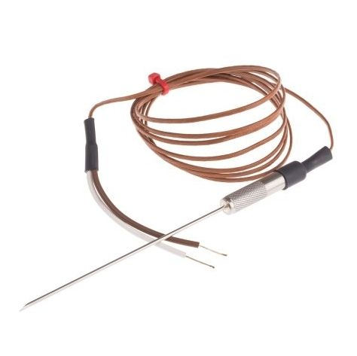

Labfacility are the UK’s leading manufacturer of Temperature Sensors, Thermocouple Connectors and associated Temperature Instrumentation and stockists of Thermocouple Cables. The Company has been trading since 1971 and is ISO 9001 accredited.

**Specifications**

|  |  |
| --- | --- |
| **Sensor Type** | chisel point Thermocouple |
| **Thermocouple Type** | T |
| **Thermocouple Junction** | Grounded hot junction |
| **Probe Diameter** | 1.6mm |
| **Probe Length** | 100mm |
| **Sheath Material** | 316 stainless steel sheath |
| **Cable Length** | 1.5m |
| **Cable Type** | PTFE insulated cable |
| **Core / Strands** | 7/0.2mm |
| **Termination Type** | Bare wire tails (+Brown/-White) |
| **Max. Temperature** | +250°C |
| **Min. Temperature** | -75°C |

**Ordering Information**

|  |  |  |  |  |
| --- | --- | --- | --- | --- |
| **Type** | **Diameter** | **Length** | **Termination** | **Order Number** |
| T | 1.6mm | 100mm | Bare Wire | XE-9511-001 |