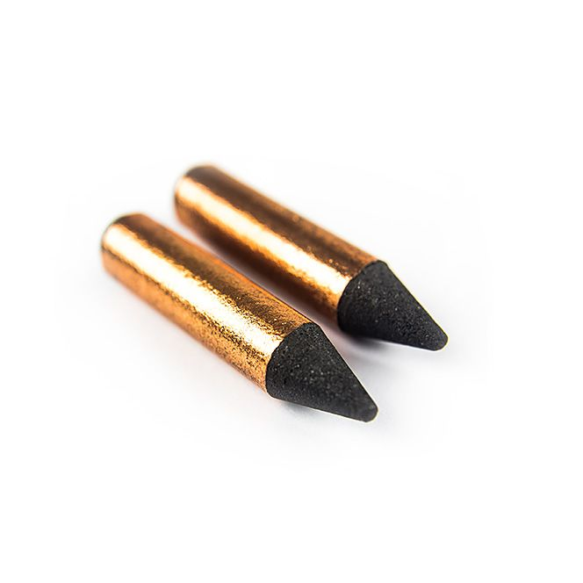

**Carbon Electrodes (x 5) for L60 Thermocouple & Fine Wire Welder**

XE-6120-001

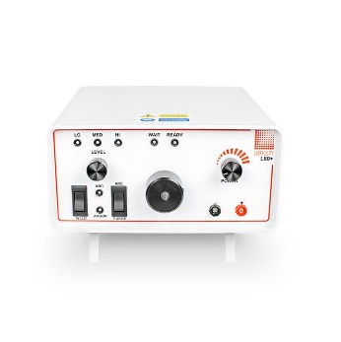

Labfacility are the UK’s leading manufacturer of Temperature Sensors, Thermocouple Connectors and associated Temperature Instrumentation and stockists of Thermocouple Cables. The Company has been trading since 1971 and is ISO 9001 accredited.

**Ordering Information**

|  |  |  |
| --- | --- | --- |
| **Style** | **Details** | **Order Number** |
| Thermocouple Welder with Accessory Kit | L60+ Welder | XE-6101-001 |
| Spare Carbon Electrodes | Pack of 5 | XE-6120-001 |