**IEC Leaf Thermocouple, Glassfibre insulated Cable with Stainless Steel Over-Braid Terminating in Standard Plug - Type K, 2m**

XE-5627-001

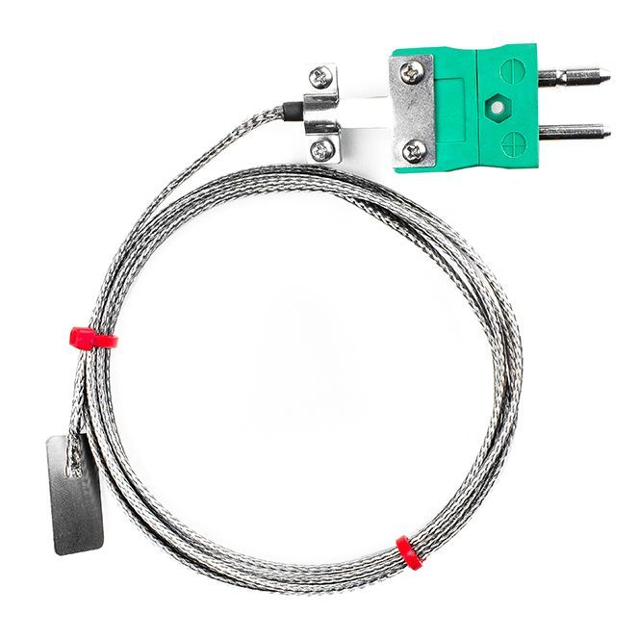

Labfacility are the UK’s leading manufacturer of Temperature Sensors, Thermocouple Connectors and associated Temperature Instrumentation and stockists of Thermocouple Cables. The Company has been trading since 1971 and is ISO 9001 accredited.

**Specifications**

|  |  |
| --- | --- |
| **General Description** | Thermocouple mounted on a stainless steel shim |
| **Thermocouple Type** | K |
| **Thermocouple Junction** | Junction grounded at tip for fast response |
| **Cable Length** | 2m |
| **Cable Type** | Glassfibre insulated lead with stainless steel overbraid |
| **Core / Strands** | 7/0.2mm |
| **Termination Type** | Standard Plug (with cable clamps) |
| **Max. Temperature** | +350°C |
| **Min. Temperature** | -60°C |
| **Dimensions** | 25x13mm shim (0.2mm thick) |

**Ordering Information**

|  |  |  |  |  |
| --- | --- | --- | --- | --- |
| **Type** | **Length** | **Cable Size** | **Termination** | **Order Number** |
| K | 2m | 7/0.2mm | Standard Plug (with cable clamps) | XE-5627-001 |