**Platinum Resistance Detectors with extended leads, Thin Film – Pt100, 500mm**

XE-5588-001

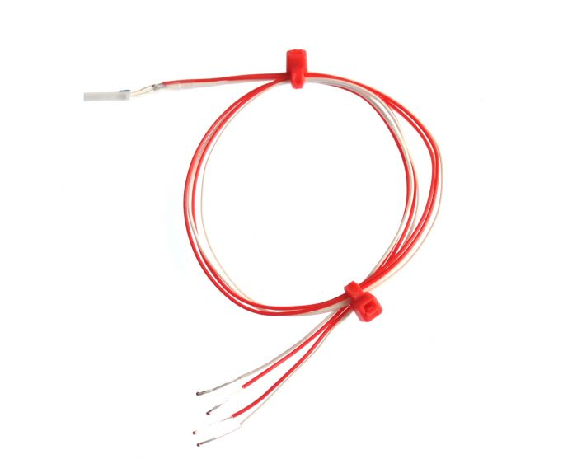

Labfacility are the UK’s leading manufacturer of Temperature Sensors, Thermocouple Connectors and associated Temperature Instrumentation and stockists of Thermocouple Cables. The Company has been trading since 1971 and is ISO 9001 accredited.

**Specifications**

|  |  |
| --- | --- |
| **General Description** | Platinum Resistance Detectors with extended leads, Thin Film |
| **Sensor Type** | Platinum Resistance, Pt100 Ohms |
| **Element** | Thin Film - Pt100 Ohm |
| **Cable Length** | 500mm |
| **Cable Type** | Teflon® insulated, stranded conductors |
| **Cable Termination** | Bare Tails |
| **Max. Temperature** | +250°C |
| **Min. Temperature** | -50°C |
| **Tolerance** | Class A |
| **Standards Met** | European / British Standard Conforms to IEC 60751:2008 / BS EN 60751:2008 |
| **Extended lead wire configuration** | 4 wire |
| **Fundamental interval** | (0°C to 100°C): 38.5 ohms nominal (100 ohms) |
| **Ice point resistance** | 100 Ohms |

**Ordering Information**

|  |  |  |  |  |  |
| --- | --- | --- | --- | --- | --- |
| **Type** | **Class** | **Length** | **Cable Size** | **Termination** | **Order Number** |
| Pt100 | A | 500mm | 7/0.15mm | Bare Tails | XE-5588-001 |