**IEC Bolt Thermocouple, Glassfibre Stainless Steel Over Braided Cable - Type K, M8 x 1mm**

XE-5563-001

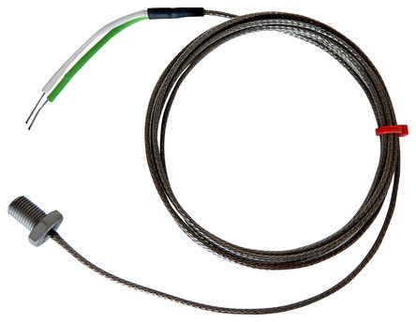

Labfacility are the UK’s leading manufacturer of Temperature Sensors, Thermocouple Connectors and associated Temperature Instrumentation and stockists of Thermocouple Cables. The Company has been trading since 1971 and is ISO 9001 accredited.

**Specifications**

|  |  |
| --- | --- |
| **Thermocouple Type** | K |
| **Thermocouple Junction** | Bolts have grounded junctions |
| **Cable Length** | 2m |
| **Cable Type** | Glassfibre stainless steel over braided cable |
| **Cable Termination** | Bare tails |
| **Max. Temperature** | +250°C |
| **Bolt thread/pitch** | M8 x 1mm |

**Ordering Information**

|  |  |  |  |  |  |
| --- | --- | --- | --- | --- | --- |
| **Type** | **Bolt** | **Bolt Length** | **Cable** | **Termination** | **Order Number** |
| K | M8 x 1mm | 13mm | 2m | Bare Tails | XE-5563-001 |