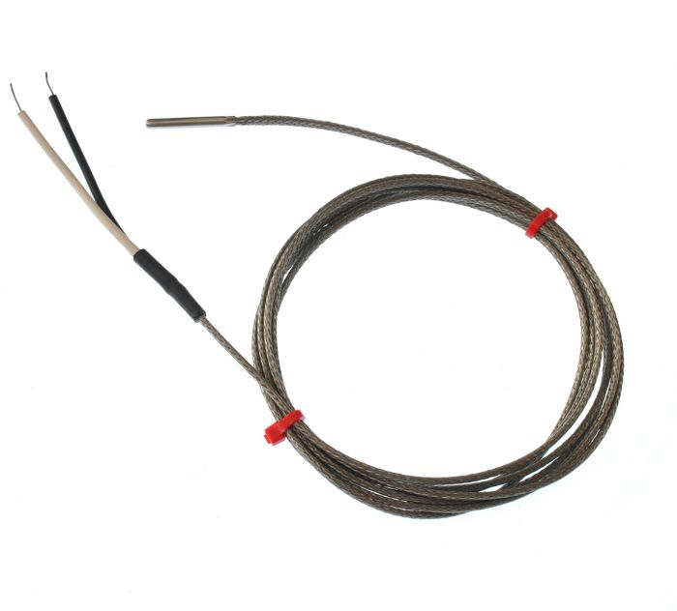

**IEC Fabricated Grounded Thermocouple in Stainless Steel Tube, Glassfibre stainless steel Overbraided cable - Type J, 4mm x 25mm**

XE-5542-001

Labfacility are the UK’s leading manufacturer of Temperature Sensors, Thermocouple Connectors and associated Temperature Instrumentation and stockists of Thermocouple Cables. The Company has been trading since 1971 and is ISO 9001 accredited.

**Specifications**

|  |  |
| --- | --- |
| **Sensor Type** | 316 stainless steel tube in various sizes |
| **Thermocouple Type** | J |
| **Thermocouple Junction** | grounded at tip for fast response |
| **Cable Length** | 2m |
| **Probe** | 4mm x 25mm |
| **Cable Type** | Glassfibre stainless steel overbraided cable |
| **Cable Termination** | Bare wire tails |
| **Max. Temperature** | +350°C |
| **Min. Temperature** | -60°C |

**Ordering Information**

|  |  |  |  |  |  |
| --- | --- | --- | --- | --- | --- |
| **Type** | **Diameter** | **Length** | **Cable** | **Termination** | **Order Number** |
| J | 4mm | 25mm | 2m | Bare Tails | XE-5542-001 |