**Moving Air Temperature Probe –**

**Type K – IEC**

XE-3845-001

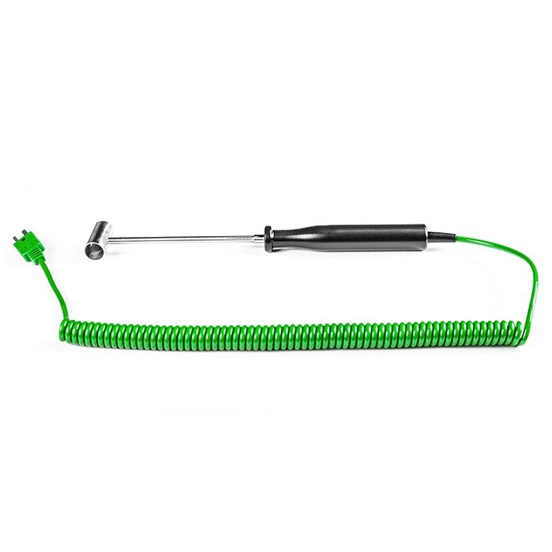

Labfacility are the UK’s leading manufacturer of Temperature Sensors, Thermocouple Connectors and associated Temperature Instrumentation and stockists of Thermocouple Cables. The Company has been trading since 1971 and is ISO 9001 accredited.

**Specifications**

|  |  |
| --- | --- |
| **General Description** | Handheld Moving Air Probe, Ideal for the measurement of air and gases |
| **Sensor Type** | Funnelled shield allows for maximum airflow across measuring junction |
| **Thermocouple Type** | K |
| **Calibration** | IEC |
| **Probe Diameter** | 30mm |
| **Probe Length** | 120mm |
| **Cable Length** | 2m |
| **Cable Termination** | Fitted Plug |

**Ordering Information**

|  |  |  |
| --- | --- | --- |
| **Thermocouple Type** | **Colour Code** | **Order Number** |
| K | IEC | XE-3845-001 |