**Surface Temperature Probe –**

**Type K – IEC**

XE-3840-001

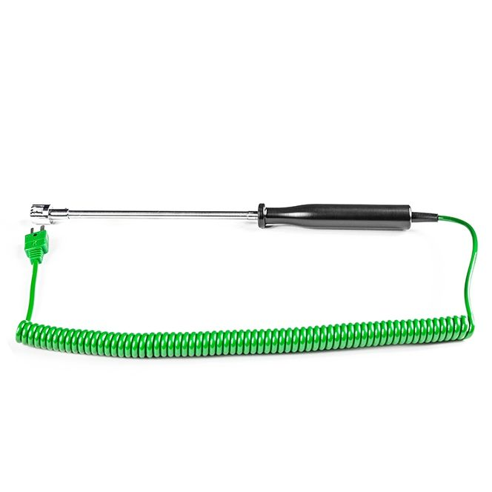

Labfacility are the UK’s leading manufacturer of Temperature Sensors, Thermocouple Connectors and associated Temperature Instrumentation and stockists of Thermocouple Cables. The Company has been trading since 1971 and is ISO 9001 accredited.

**Specifications**

|  |  |
| --- | --- |
| **General Description** | Handheld Surface Probe |
| **Thermocouple Type** | K |
| **Calibration** | IEC |
| **Probe Diameter** | 15mm |
| **Probe Length** | 170mm |
| **Sheath Material** | Stainless steel sheath |
| **Cable Length** | 2m |
| **Cable Termination** | Fitted Plug |
| **Max. Temperature** | 400°C |

**Ordering Information**

|  |  |  |
| --- | --- | --- |
| **Thermocouple Type** | **Colour Code** | **Order Number** |
| K | IEC | XE-3840-001 |