**KNE Terminal Head**

XE-3821-001

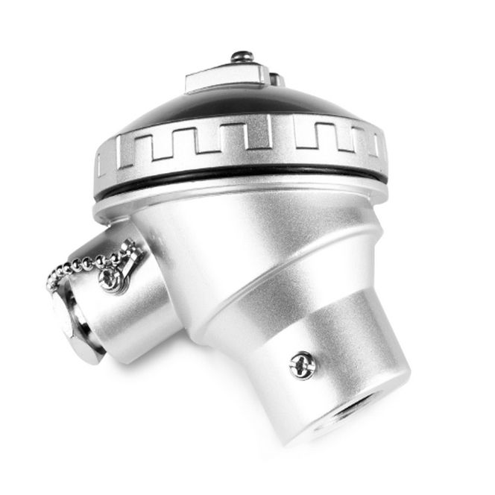

Labfacility are the UK’s leading manufacturer of Temperature Sensors, Thermocouple Connectors and associated Temperature Instrumentation and stockists of Thermocouple Cables. The Company has been trading since 1971 and is ISO 9001 accredited.

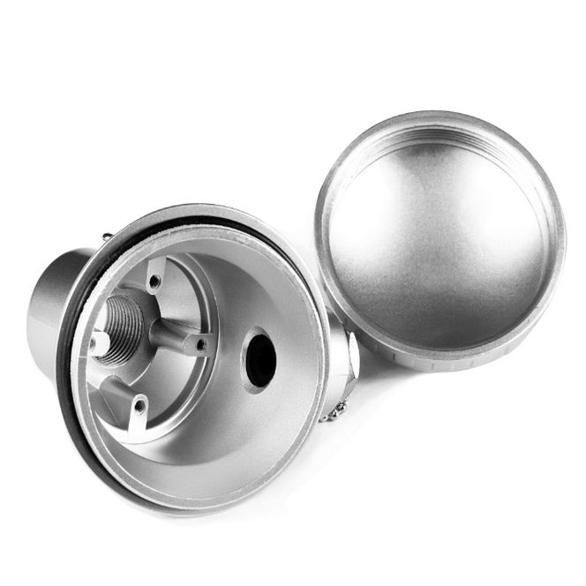

**Specifications**

|  |  |
| --- | --- |
| **Head Type** | KNE Standard Head |
| **Material** | Aluminium silver painted |
| **Cable Entry** | M20 x 1.5mm |
| **Fixing (Centres)** | 33mm & 40mm |
| **Max. Temperature** | 170°C |
| **IP Rating** | IP67 rated |
| **Process Entry** | 1/2" BSPP |
| **Cap Retaining Type** | Screw cap and retaining screw |

**Ordering Information**

|  |  |
| --- | --- |
| **Head Type** | **Order Number** |
| KNE | XE-3821-001 |