**Right Angled Surface Temperature Probe –**

**Type K – IEC**

XE-3819-001

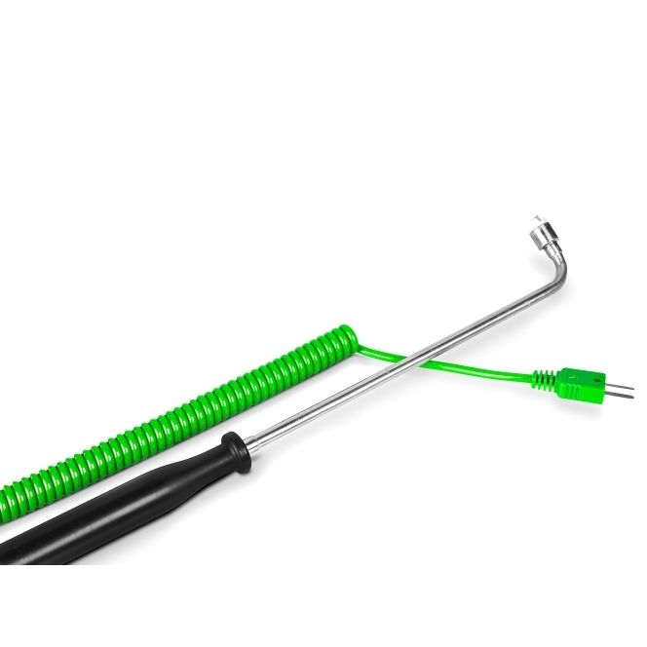

Labfacility are the UK’s leading manufacturer of Temperature Sensors, Thermocouple Connectors and associated Temperature Instrumentation and stockists of Thermocouple Cables. The Company has been trading since 1971 and is ISO 9001 accredited.

**Specifications**

|  |  |
| --- | --- |
| **General Description** | Surface temperature fast response thermocouple |
| **Sensor Type** | Right angled Probe |
| **Thermocouple Type** | K |
| **Calibration** | IEC |
| **Cable Length** | 2m |
| **Cable Termination** | Fitted Plug |
| **Max. Temperature** | +900°C |
| **Dimensions** | Probe Ø12mm Tip x 40mm Hot Leg and Ø6mm x 180mm Cold Leg. Coiled element diameter 7mm |
| **Tip** | Ceramic Tip, Coiled Element |

**Ordering Information**

|  |  |  |
| --- | --- | --- |
| **Thermocouple Type** | **Colour Code** | **Order Number** |
| K | IEC | XE-3819-001 |