**Surface Temperature Probe - 90mm long with 10mm tip – Type K – IEC**

XE-3818-001

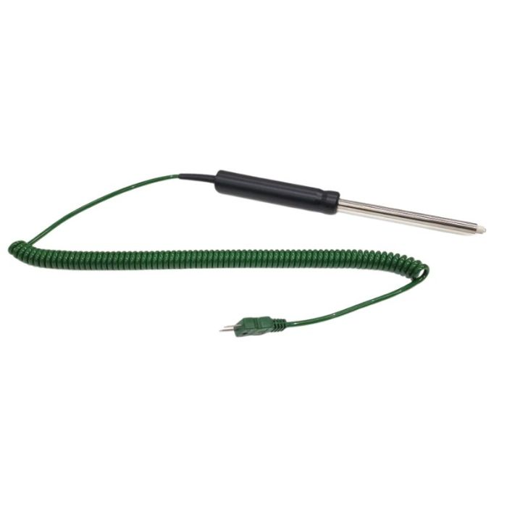

Labfacility are the UK’s leading manufacturer of Temperature Sensors, Thermocouple Connectors and associated Temperature Instrumentation and stockists of Thermocouple Cables. The Company has been trading since 1971 and is ISO 9001 accredited.

**Specifications**

|  |  |
| --- | --- |
| **General Description** | Surface temperature fast response thermocouple with ceramic tip and coiled element |
| **Thermocouple Type** | K |
| **Calibration** | IEC |
| **Cable Length** | 2m |
| **Cable Termination** | Fitted Plug |
| **Max. Temperature** | +900°C |
| **Dimensions** | Probe Ø6 x 90mm long stem with Ø12 x 10mm tip. Coiled element diameter 7mm |

**Ordering Information**

|  |  |  |
| --- | --- | --- |
| **Thermocouple Type** | **Colour Code** | **Order Number** |
| K | IEC | XE-3818-001 |