**Right Angled Handheld Probe- Copper Disc Tip –**

**Type K – IEC**

XE-3817-001

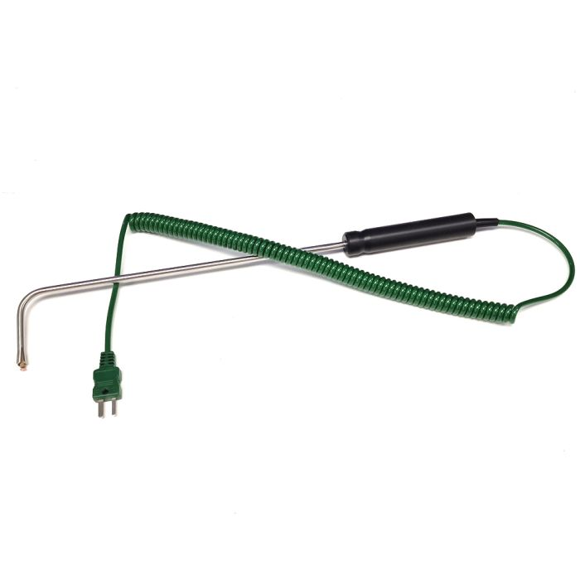

Labfacility are the UK’s leading manufacturer of Temperature Sensors, Thermocouple Connectors and associated Temperature Instrumentation and stockists of Thermocouple Cables. The Company has been trading since 1971 and is ISO 9001 accredited.

**Specifications**

|  |  |
| --- | --- |
| **General Description** | Surface temperature spring loaded thermocouple with right angled probe and copper disc tip |
| **Thermocouple Type** | K |
| **Calibration** | IEC |
| **Cable Length** | 2m |
| **Cable Termination** | Fitted Plug |
| **Max. Temperature** | +600°C |
| **Dimensions** | Probe Ø8mm(17mmL) Tip x 60mm Hot Leg and Ø6mm x 180mm Cold Leg with Ø4.5mm copper disc. |

**Ordering Information**

|  |  |  |
| --- | --- | --- |
| **Thermocouple Type** | **Colour Code** | **Order Number** |
| K | IEC | XE-3817-001 |