**Handheld Spring Loaded Thermocouple with Copper Disc Tip - Type K – IEC**

XE-3816-001

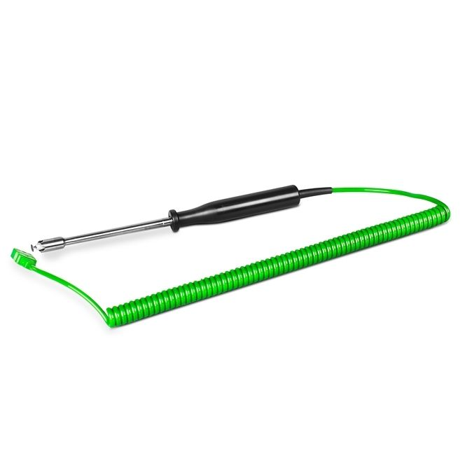

Labfacility are the UK’s leading manufacturer of Temperature Sensors, Thermocouple Connectors and associated Temperature Instrumentation and stockists of Thermocouple Cables. The Company has been trading since 1971 and is ISO 9001 accredited.

**Specifications**

|  |  |
| --- | --- |
| **General Description** | Surface temperature spring loaded thermocouple with copper disc tip |
| **Thermocouple Type** | K |
| **Calibration** | IEC |
| **Cable Length** | 2m Fully Extended |
| **Cable Type** | Retractable Curly Thermocouple Lead - Polyurethane outer |
| **Cable Termination** | Miniature Plug |
| **Max. Temperature** | +600°C |
| **Dimensions** | Probe 4.7mmØ x 63mm long stem, Ø8 x 17mm tip with Ø4.5mm copper disc |
| **Tip** | Copper disc tip |

**Ordering Information**

|  |  |  |
| --- | --- | --- |
| **Thermocouple Type** | **Colour Code** | **Order Number** |
| K | IEC | XE-3816-001 |