**Handheld Mineral Insulated General Purpose Probe – Type K – IEC**

XE-3806-001

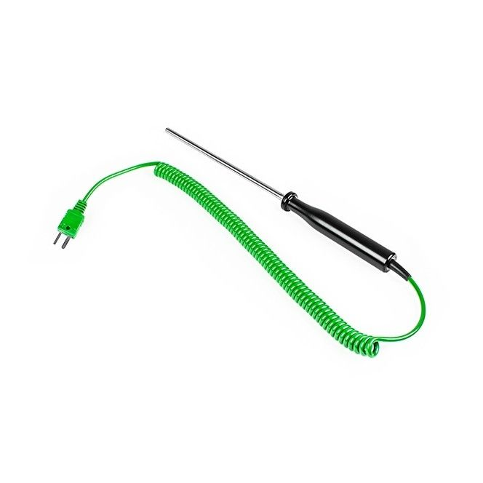

Labfacility are the UK’s leading manufacturer of Temperature Sensors, Thermocouple Connectors and associated Temperature Instrumentation and stockists of Thermocouple Cables. The Company has been trading since 1971 and is ISO 9001 accredited.

**Specifications**

|  |  |
| --- | --- |
| **General Description** | Rounded tip suitable for semi solid and liquid temperature measurement |
| **Thermocouple Type** | K |
| **Calibration** | IEC |
| **Probe Diameter** | 1.5mm |
| **Probe Length** | 100mm |
| **Cable Length** | 2m Coiled Cable |
| **Termination Type** | Fitted Mini Plug |
| **Max. Temperature** | +850°C |

**Ordering Information**

|  |  |  |
| --- | --- | --- |
| **Thermocouple Type** | **Colour Code** | **Order Number** |
| K | IEC | XE-3806-001 |