**Stainless Steel Air Temperature Probe –**

**Type K – IEC**

XE-3800-001

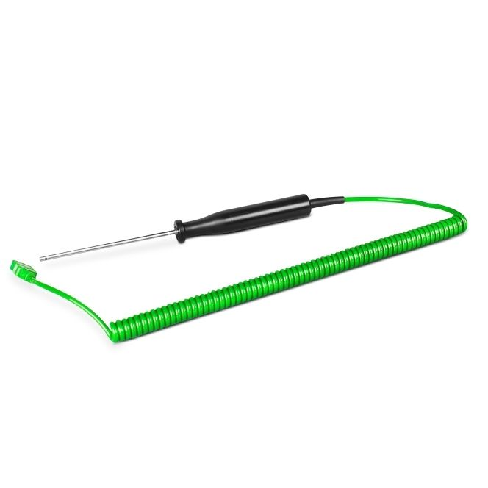

Labfacility are the UK’s leading manufacturer of Temperature Sensors, Thermocouple Connectors and associated Temperature Instrumentation and stockists of Thermocouple Cables. The Company has been trading since 1971 and is ISO 9001 accredited.

**Specifications**

|  |  |
| --- | --- |
| **General Description** | 316 Stainless Steel Air Probe with a vented sheath for general air temperature measurement. |
| **Sensor Type** | K |
| **Calibration** | IEC |
| **Probe Diameter** | 4.0mm |
| **Probe Length** | 110mm |
| **Sheath Material** | 316 Stainless Steel |
| **Cable Type** | 2m Coiled Cable |
| **Cable Termination** | Fitted plug |
| **Max. Temperature** | +400°C |

**Ordering Information**

|  |  |  |
| --- | --- | --- |
| **Thermocouple Type** | **Colour Code** | **Order Number** |
| K | IEC | XE-3800-001 |