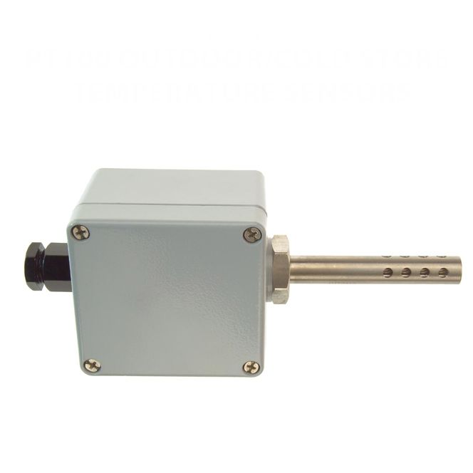

**Pt100 Outdoor / Cold Store Temperature Sensors with 4-20mA Output -**

**Type PRT**

XE-3675-001

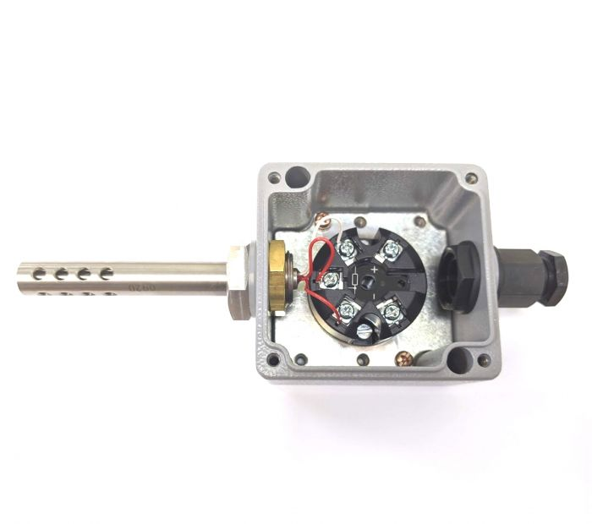

Labfacility are the UK’s leading manufacturer of Temperature Sensors, Thermocouple Connectors and associated Temperature Instrumentation and stockists of Thermocouple Cables. The Company has been trading since 1971 and is ISO 9001 accredited.

Includes integral transmitter which converts the Pt100 sensor output to a standard industrial 4 to 20mA output signal over pre-configured range of -50 to +150°C. It is also configurable by the user allowing range and burnout direction to be changed. It also allows the user to trim output current at either 4 or 20mA.

3 wire single element with transmitter, 4-20mA 2 wire current loop output, default range -50 to +150°C (other ranges can be scaled/configured by user, 25°C minimum span)

**Specifications**

|  |  |
| --- | --- |
| **General Description** | Weatherproof IP67 rated wall mounting Pt100 for accurate outdoor air temperature sensing |
| **Sensor Type** | single element with 4-20mA output |
| **Housing** | Painted Die-Cast Aluminium Housing L80 x W74 x H54mm |
| **Element** | Pt100, class B to IEC 751 |
| **Sheath Material** | Perforated 316 stainless steel probe, 12.7mm x 75mm |
| **Gland** | M20 cable entry gland |
| **Max. Temperature** | +150°C |
| **Min. Temperature** | -50°C |
| **IP Rating** | IP67 |
| **Transmitter** | Yes |
| **Number of Wires** | 3 |

**Ordering Information**

|  |  |  |
| --- | --- | --- |
| **Type** | **Transmitter** | **Order Number** |
| Pt100 | Yes | XE-3675-001 |