**Stainless Steel Sheathed Pt100 Sensor –**

**Type PRT**

XE-3665-001

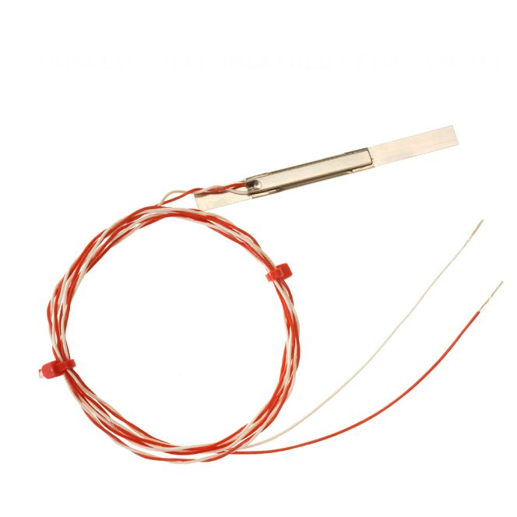

Labfacility are the UK’s leading manufacturer of Temperature Sensors, Thermocouple Connectors and associated Temperature Instrumentation and stockists of Thermocouple Cables. The Company has been trading since 1971 and is ISO 9001 accredited.

**Specifications**

|  |  |
| --- | --- |
| **General Description** | Sheathed Pt100 element in a thin, flat stainless steel body |
| **Sensor Type** | Quick thermal response while element remains protected |
| **Element** | Pt100 |
| **Cable Length** | 1m |
| **Cable Type** | Teflon® insulated twin twisted lead |
| **Core / Strands** | 7/0.2mm |
| **Cable Termination** | Bare Tails |
| **Max. Temperature** | +250°C |
| **Min. Temperature** | -50°C |
| **Accuracy** | Class B |
| **Number of Wires** | 2 |

**Ordering Information**

|  |  |  |  |
| --- | --- | --- | --- |
| **Type** | **Length** | **Termination** | **Order Number** |
| Pt100 | 1m | Bare Tails | XE-3665-001 |