**Self Adhesive Patch PT1000 Sensor –**

**Type PRT, 1m**

XE-3662-001

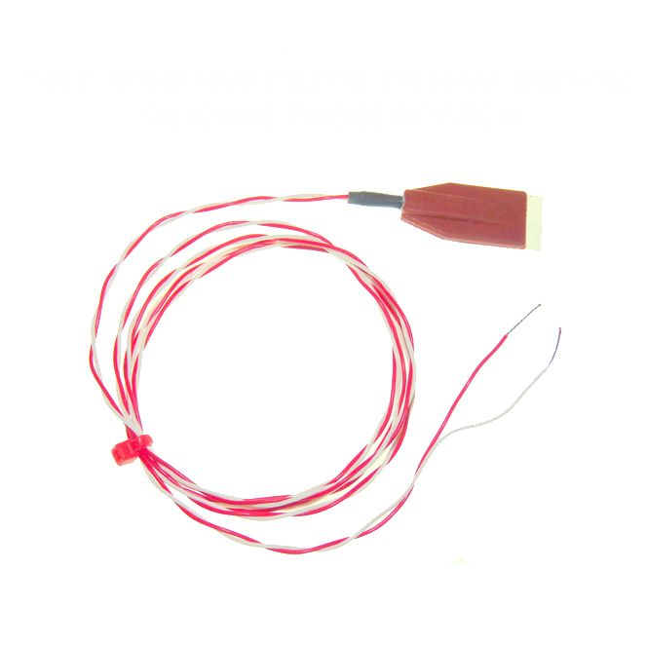

Labfacility are the UK’s leading manufacturer of Temperature Sensors, Thermocouple Connectors and associated Temperature Instrumentation and stockists of Thermocouple Cables. The Company has been trading since 1971 and is ISO 9001 accredited.

**Specifications**

|  |  |
| --- | --- |
| **General Description** | Pt1000 element encapsulated in a silicone rubber patch, Self-adhesive, aluminium foil backing. |
| **Sensor Type** | Pt1000 (1000Ω @ 0°C), thin film Class B to IEC751 |
| **Element** | Pt1000 sensor to IEC751 Class B |
| **Patch dimensions** | Length 30mm x Width 15mm x Height 4mm |
| **Cable Length** | 1m |
| **Cable Type** | Teflon ® insulated twin twisted |
| **Core / Strands** | 7/0.2mm |
| **Cable Termination** | Bare Tails |
| **Max. Temperature** | +150°C |
| **Min. Temperature** | -50°C |

**Ordering Information**

|  |  |  |  |
| --- | --- | --- | --- |
| **Type** | **Length** | **Termination** | **Order Number** |
| Pt1000 | 1m | Bare Tails | XE-3662-001 |