**Self Adhesive Patch PT100 Sensor –**

**Type PRT, 5m**

XE-3661-001

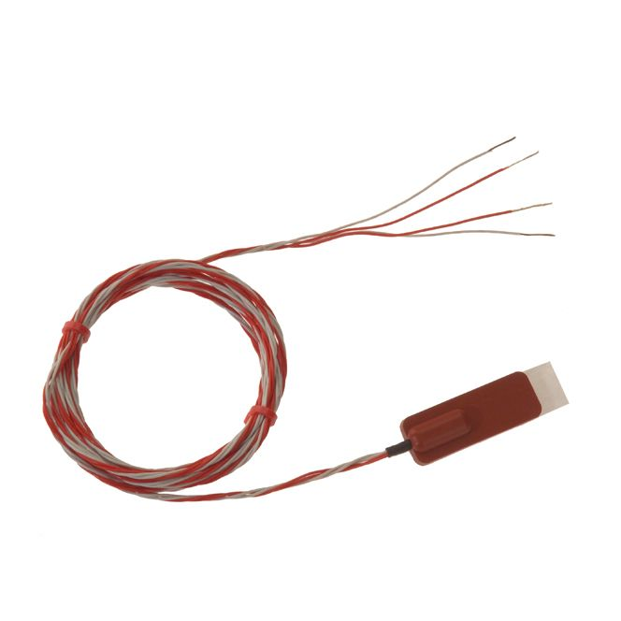

Labfacility are the UK’s leading manufacturer of Temperature Sensors, Thermocouple Connectors and associated Temperature Instrumentation and stockists of Thermocouple Cables. The Company has been trading since 1971 and is ISO 9001 accredited.

**Specifications**

|  |  |
| --- | --- |
| **General Description** | Suitable for general purpose industrial & commercial use |
| **Sensor Type** | Silicone rubber patch with self-adhesive foil backing |
| **Element** | Pt100 |
| **Patch dimensions** | L40 x W15mm |
| **Cable Length** | 5m |
| **Cable Type** | PTFE insulated twisted leads |
| **Core / Strands** | 7/0.2mm |
| **Cable Termination** | Bare Tails |
| **Termination Type** | 4-wire tails allows connection to any PT100 instrument 2, 3 or 4 wire |
| **Max. Temperature** | +150°C |
| **Min. Temperature** | -50°C |
| **Accuracy** | class B |
| **Number of Wires** | 4 |

**Ordering Information**

|  |  |  |  |
| --- | --- | --- | --- |
| **Type** | **Length** | **Termination** | **Order Number** |
| Pt100 | 5m | Bare Tails | XE-3661-001 |