**Pt100 4 wire class B Resistance Thermometer with 1/2"BSP Process Connection, KNE Head,**

**6mm x 150mm**

XE-3649-001

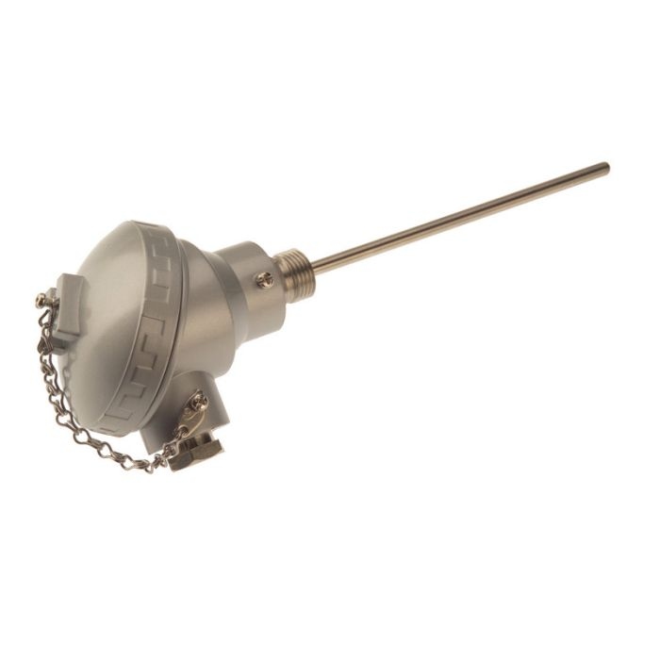

Labfacility are the UK’s leading manufacturer of Temperature Sensors, Thermocouple Connectors and associated Temperature Instrumentation and stockists of Thermocouple Cables. The Company has been trading since 1971 and is ISO 9001 accredited.

**Specifications**

|  |  |
| --- | --- |
| **Sensor Type** | Pt100 (100 Ohms @ 0°C) to IEC 751, Class B, 4 wire |
| **Probe Diameter** | 6mm |
| **Probe Length** | 150mm |
| **Sheath Material** | 316 stainless steel |
| **Head Type** | KNE |
| **Termination Type** | 4 wire connection block, M20 x 1.5mm cable entry (gland included) |
| **Process Connection** | 1/2"BSP parallel |
| **Max. Temperature** | +450°C (connection head @ 170°C) |
| **Min. Temperature** | -50°C |
| **IP Rating** | IP67 |
| **Accuracy** | Class B |
| **Number of Wires** | 4 |

**Ordering Information**

|  |  |  |  |  |
| --- | --- | --- | --- | --- |
| **Type** | **Diameter** | **Length** | **Termination** | **Order Number** |
| Pt100 | 6mm | 150mm | KNE Head | XE-3649-001 |