**Thermo Attachment Pads in PTFE glass cloth**

XE-3599-001

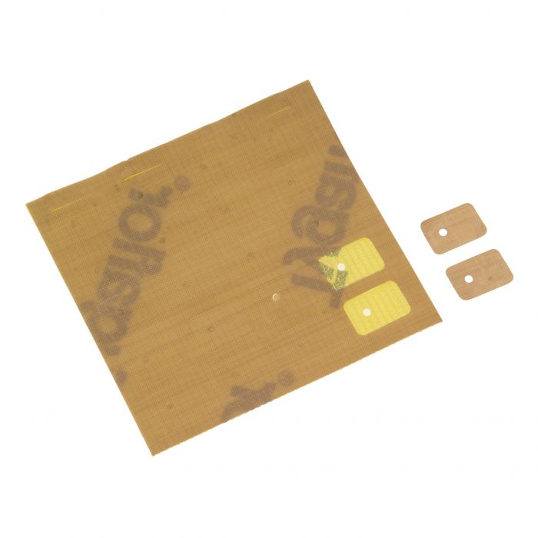

Labfacility are the UK’s leading manufacturer of Temperature Sensors, Thermocouple Connectors and associated Temperature Instrumentation and stockists of Thermocouple Cables. The Company has been trading since 1971 and is ISO 9001 accredited.



**Specifications**

* Self-adhesive pads in PTFE glass cloth for locating welded tip thermocouples
* Rated -73°C to 260°C
* Pad size 13x18mm
* Sheet contains 20 pads

**Ordering Information**

|  |  |
| --- | --- |
| **Pack Size** | **Order Number** |
| 20 pads | XE-3599-001 |