**PFA Insulated Exposed Junction thermocouple with Bare Tails ANSI –**

**Type K, 2m**

XE-3550-001

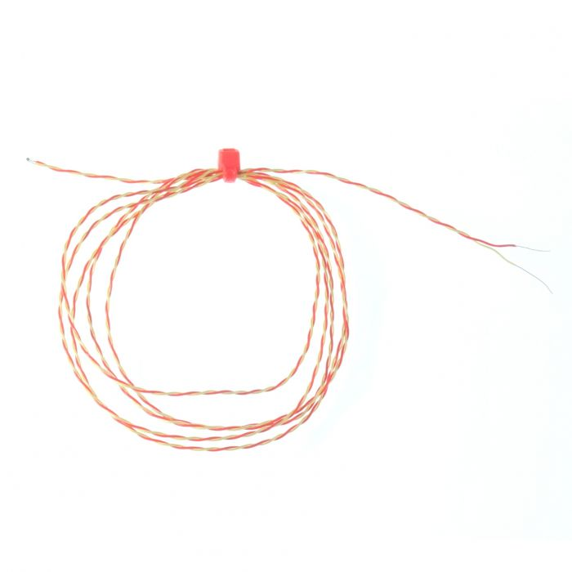

Labfacility are the UK’s leading manufacturer of Temperature Sensors, Thermocouple Connectors and associated Temperature Instrumentation and stockists of Thermocouple Cables. The Company has been trading since 1971 and is ISO 9001 accredited.

**Specifications**

|  |  |
| --- | --- |
| **General Description** | Fast response, welded exposed junction |
| **Thermocouple Type** | K |
| **Thermocouple Junction** | Exposed |
| **Cable Length** | 2m |
| **Cable Type** | Teflon® PFA insulated twin-twisted lead |
| **Core / Strands** | 7/0.2mm |
| **Cable Termination** | Bare wire |
| **Max. Temperature** | +250°C |
| **Min. Temperature** | -75°C |
| **Standards Met** | ANSI MC96.1 |

**Ordering Information**

|  |  |  |  |  |  |
| --- | --- | --- | --- | --- | --- |
| **Thermocouple Type** | **Colour Code** | **Core/Strands** | **Length** | **Termination** | **Order Number** |
| K | ANSI | 7/0.2mm | 2m | Bare Wire | XE-3550-001 |