**PFA Insulated IEC Fine Gauge Exposed Junction Thermocouple (0.076mm conductors) –**

**Type K, 2m**

XE-3511-001

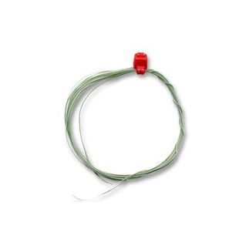

Labfacility are the UK’s leading manufacturer of Temperature Sensors, Thermocouple Connectors and associated Temperature Instrumentation and stockists of Thermocouple Cables. The Company has been trading since 1971 and is ISO 9001 accredited.

**Specifications**

|  |  |
| --- | --- |
| **General Description** | Fast response, welded tip exposed junction |
| **Sensor Type** | Exposed Junction |
| **Thermocouple Type** | K |
| **Cable Length** | 2m |
| **Cable Type** | Teflon® PFA insulated wires |
| **Core / Strands** | 0.003" (0.076mm) conductors |
| **Termination Type** | Bare tails |
| **Max. Temperature** | +260°C |
| **Min. Temperature** | -75°C |
| **Standards Met** | IEC-584-3 |

**Ordering Information**

|  |  |  |  |  |  |
| --- | --- | --- | --- | --- | --- |
| **Thermocouple Type** | **Colour Code** | **Core/Strands** | **Length** | **Termination** | **Order Number** |
| K | IEC | 0.076mm | 2m | Bare Tails | XE-3511-001 |