**PFA Insulated Flat Pair IEC Exposed Junction Thermocouple with Miniature Plug - Type K, 2m**

XE-3489-001

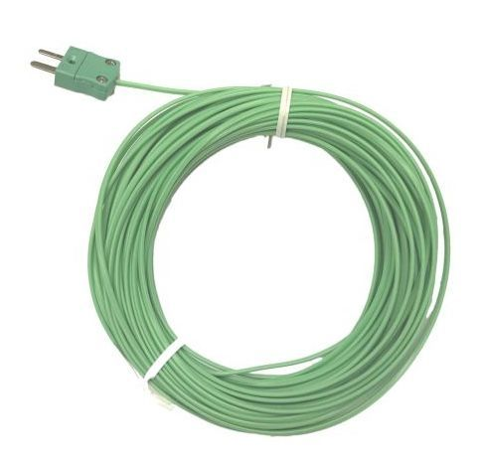

Labfacility are the UK’s leading manufacturer of Temperature Sensors, Thermocouple Connectors and associated Temperature Instrumentation and stockists of Thermocouple Cables. The Company has been trading since 1971 and is ISO 9001 accredited.

**Specifications**

|  |  |
| --- | --- |
| **Sensor Type** | Fast response, welded exposed junction |
| **Thermocouple Type** | Thermocouple type K |
| **Cable Connection** | Terminated with a miniature flat pin plug |
| **Cable Length** | 2m PFA |
| **Core / Strands** | 1/0.5mm |
| **Termination Type** | Miniature Plug |
| **Standards Met** | (cores & jacket) to IEC-584-3 |
| **Insulation Material** | Insulation rating: -75°C to 260°C |

**Ordering Information**

|  |  |  |  |  |  |
| --- | --- | --- | --- | --- | --- |
| **Thermocouple Type** | **Colour Code** | **Core/Strands** | **Length** | **Termination** | **Order Number** |
| K | IEC | 1/0.5mm | 2m | Miniature Plug | XE-3489-001 |