**IEC Type K 3kg Pull Magnet Thermocouple, PFA Insulated Cable with Stainless Steel Over-Braid Terminating in Miniature Plug –**

**Type K, 2m**

XE-3470-001

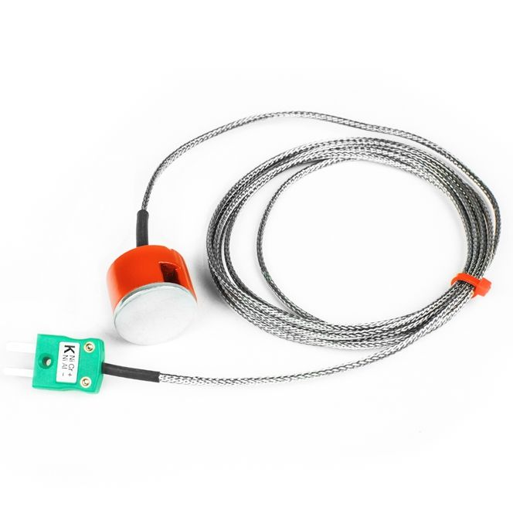

Labfacility are the UK’s leading manufacturer of Temperature Sensors, Thermocouple Connectors and associated Temperature Instrumentation and stockists of Thermocouple Cables. The Company has been trading since 1971 and is ISO 9001 accredited.

**Specifications**

|  |  |
| --- | --- |
| **General Description** | Rapid, reliable temperature sensing on ferrous surfaces |
| **Thermocouple Type** | K |
| **Thermocouple Junction** | Grounded measuring junction |
| **Magnet** | 1” diameter (3kg pull) |
| **Cable Length** | 2 metre |
| **Cable Type** | stainless steel over-braided PFA Teflon® |
| **Cable Termination** | Fitted Miniature or Standard Plug |
| **Max. Temperature** | +250°C (200°C Plug) |

**Ordering Information**

|  |  |  |  |  |  |
| --- | --- | --- | --- | --- | --- |
| **Thermocouple Type** | **Colour Code** | **Magnet Pull** | **Length** | **Termination** | **Order Number** |
| K | IEC | 3kg | 2m | Miniature Plug | XE-3470-001 |