**IEC General Purpose Thermocouple Probe, Glassfibre insulated Cable with Stainless Steel Over-Braid Terminating in Bare tails –**

**Type J, 2m**

XE-3400-001

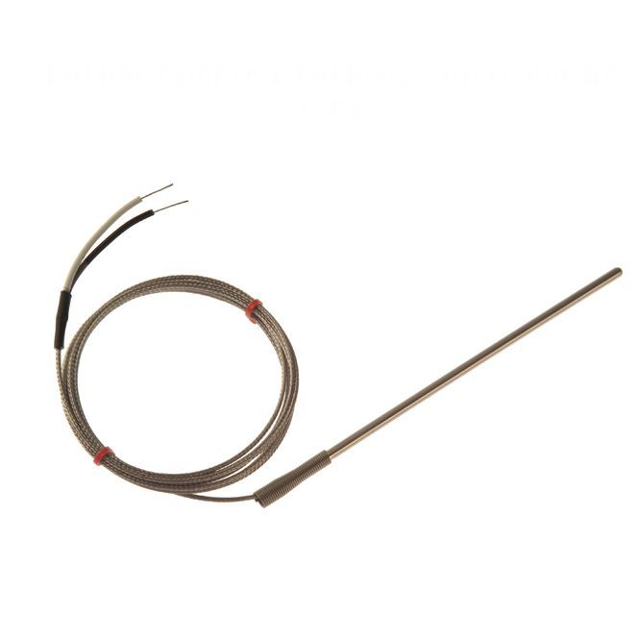

Labfacility are the UK’s leading manufacturer of Temperature Sensors, Thermocouple Connectors and associated Temperature Instrumentation and stockists of Thermocouple Cables. The Company has been trading since 1971 and is ISO 9001 accredited.

**Specifications**

|  |  |
| --- | --- |
| **General Description** | Rugged thermocouple with stainless steel sheath |
| **Thermocouple Type** | J |
| **Thermocouple Junction** | Grounded hot junction for fast response |
| **Probe Diameter** | 4.5mm |
| **Probe Length** | 150mm |
| **Cable Length** | 2m |
| **Cable Type** | Glassfibre insulated lead with stainless steel overbraid |
| **Core / Strands** | 7/0.2mm |
| **Termination Type** | Bare tails |
| **Max. Temperature** | +350°C |
| **Min. Temperature** | -60°C |

**Ordering Information**

|  |  |  |  |  |  |
| --- | --- | --- | --- | --- | --- |
| **Thermocouple Type** | **Colour Code** | **Diameter** | **Length** | **Termination** | **Order Number** |
| J | IEC | 4.5mm | 150mm | Bare Tails | XE-3400-001 |