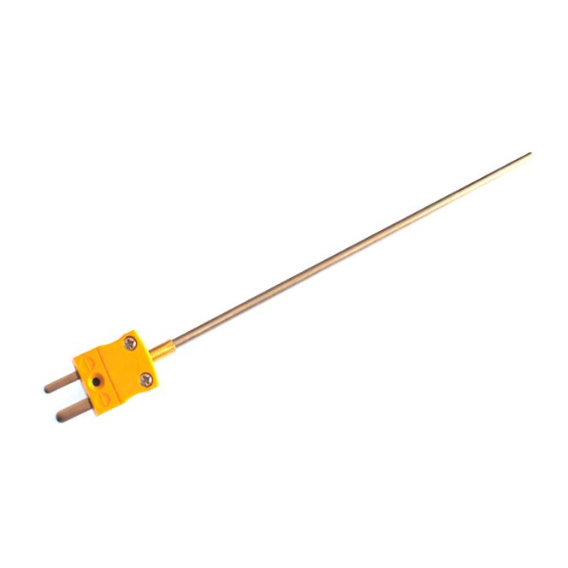

**Mineral Insulated Thermocouple with Miniature Plug ANSI –**

**Type K, 1mm x 150mm**

XE-3010-001

Labfacility are the UK’s leading manufacturer of Temperature Sensors, Thermocouple Connectors and associated Temperature Instrumentation and stockists of Thermocouple Cables. The Company has been trading since 1971 and is ISO 9001 accredited.

**Specifications**

|  |  |
| --- | --- |
| **Thermocouple Type** | K |
| **Thermocouple Junction** | Hot junction insulated from sheath |
| **Probe Diameter** | 1.0mm |
| **Probe Length** | 150mm |
| **Sheath Material** | Stainless steel 310 sheath |
| **Termination Type** | Miniature Plug |
| **Max. Temperature** | +750°C |
| **Standards Met** | ANSI |

**Ordering Information**

|  |  |  |  |  |  |
| --- | --- | --- | --- | --- | --- |
| **Thermocouple Type** | **Colour Code** | **Diameter** | **Length** | **Termination** | **Order Number** |
| K | ANSI | 1.0mm | 150mm | Miniature Plug | XE-3010-001 |