**Thermocouple Spade Terminals Type K**

XE-1982-020

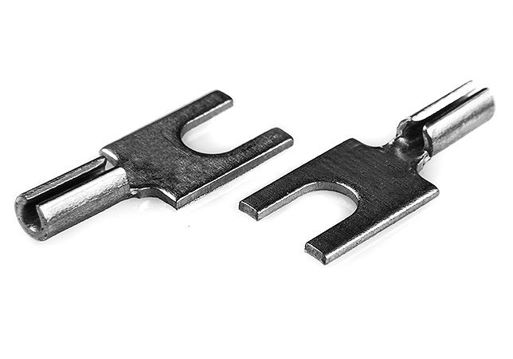

Labfacility are the UK’s leading manufacturer of Temperature Sensors, Thermocouple Connectors and associated Temperature Instrumentation and stockists of Thermocouple Cables. The Company has been trading since 1971 and is ISO 9001 accredited.

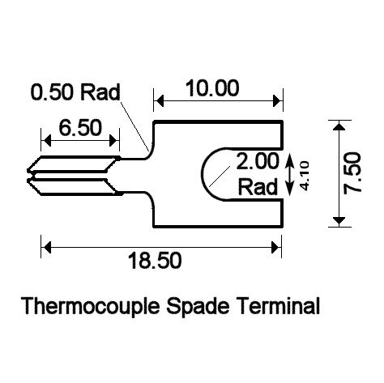

**Specifications**

* Crimp-on spade terminals
* Price per pack of 20 pairs
* Suitable for IEC, ANSI and JIS calibration types.
* Made from compatible thermocouple material
* Thermocouple type stamped on terminal
* Suits Labfacility & other barrier terminals
* For wire sizes 0.5 to 1.0 mm

|  |  |
| --- | --- |
| **+Positive Contact** | Nickel Chromium |
| **-Negative Contact** | Nickel Alloy |

**Ordering Information**

|  |  |  |
| --- | --- | --- |
| **Thermocouple Type** | **Pack Size** | **Order Number** |
| K | 20 pairs | XE-1982-020 |