**Barrier Terminal Block Thermocouple Connector IS-K-BTS Type K IEC**

XE-1940-001

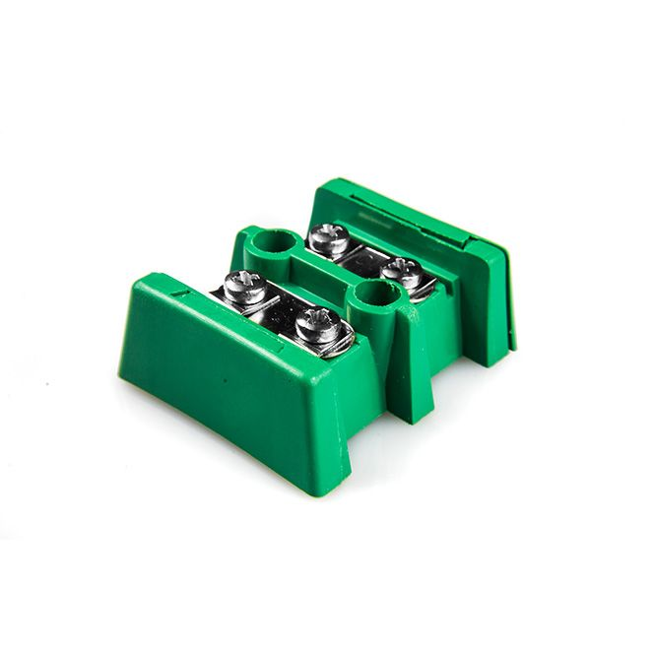

Labfacility are the UK’s leading manufacturer of Temperature Sensors, Thermocouple Connectors and associated Temperature Instrumentation and stockists of Thermocouple Cables. The Company has been trading since 1971 and is ISO 9001 accredited.

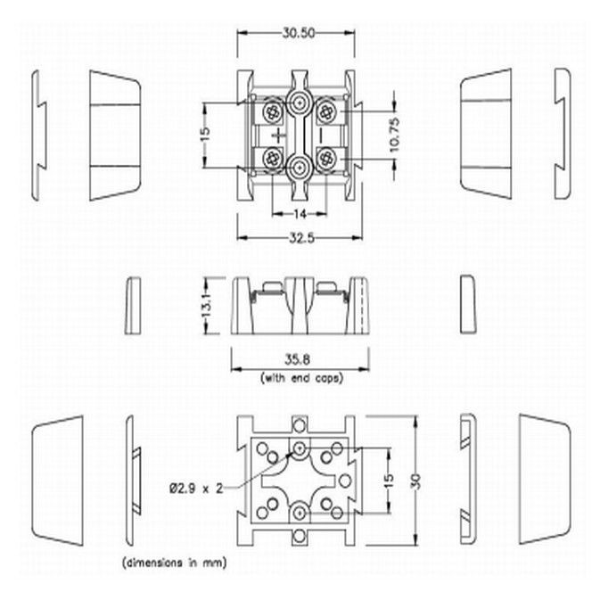

**Specifications**

|  |  |
| --- | --- |
| **General Description** | Supplied in single, interlocking pairs. Connections in thermocouple material |
| **Thermocouple Type** | K IEC |
| **Connector Type** | Barrier Terminal Blocks |
| **Colour** | Green |
| **Max. Temperature** | 220°C |
| **+Positive Contact** | Nickel Chromium |
| **-Negative Contact** | Nickel Alloy |
| **Standards Met** | BS EN 50212:1997. RoHS |

**Ordering Information**

|  |  |  |
| --- | --- | --- |
| **Type** | **Manufacturers Number** | **Order Number** |
| K | IS-K-TBS | XE-1940-001 |