**Strain Relief Grommet**

XE-1882-001

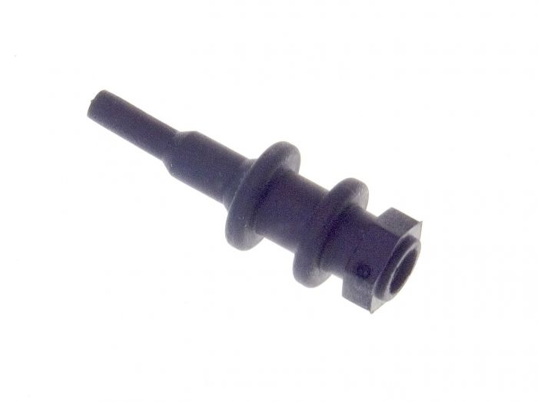

Labfacility are the UK’s leading manufacturer of Temperature Sensors, Thermocouple Connectors and associated Temperature Instrumentation and stockists of Thermocouple Cables. The Company has been trading since 1971 and is ISO 9001 accredited.

**Specifications**

* Strain Relief Grommet for Miniature Connectors
* Temperature Rating: -30°C to +140°C
* Material: Thermoplastic elastomer (TPE)
* 25 per pack

**Ordering Information**

|  |  |  |  |
| --- | --- | --- | --- |
| **Size** | **Manufacturers Number** | **Pack Size** | **Order Number** |
| Miniature | Grommet | 25 per pack | XE-1882-001 |

