**Miniature Thermocouple Cable / Wire Clamps**

XE-1760-001

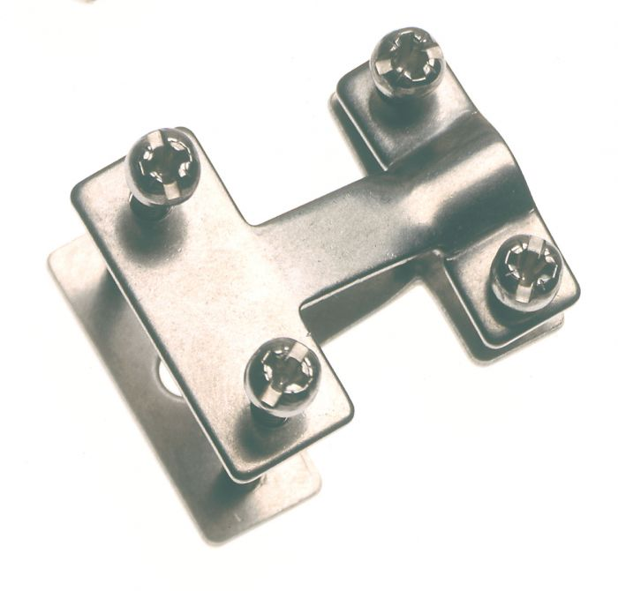

Labfacility are the UK’s leading manufacturer of Temperature Sensors, Thermocouple Connectors and associated Temperature Instrumentation and stockists of Thermocouple Cables. The Company has been trading since 1971 and is ISO 9001 accredited.

**Specifications**

* Cable clamp for miniature type thermocouple connectors
* Suitable with most types of in-line plugs & socket types
* For secure fastening between cable and connector
* For use with cables above 3.0mm diameter
* Made from stainless steel
* Quick & easy to fit

**Ordering Information**

|  |  |  |
| --- | --- | --- |
| **Size** | **Manufacturers Number** | **Order Number** |
| Miniature | FMTC-EXCL | XE-1760-001 |