**Standard Thermocouple Connector Plug**

**IS-J-M Type J IEC**

XE-1460-001

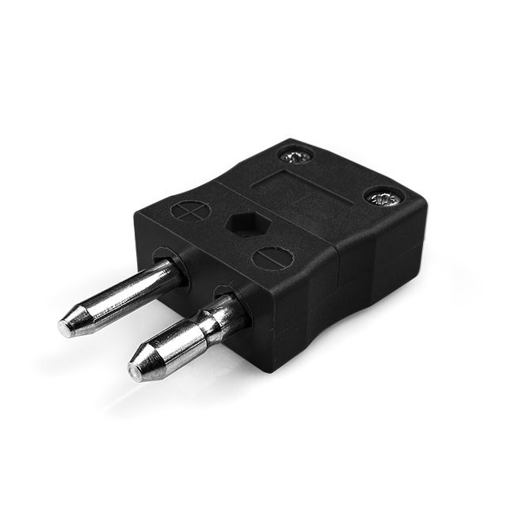

Labfacility are the UK’s leading manufacturer of Temperature Sensors, Thermocouple Connectors and associated Temperature Instrumentation and stockists of Thermocouple Cables. The Company has been trading since 1971 and is ISO 9001 accredited.

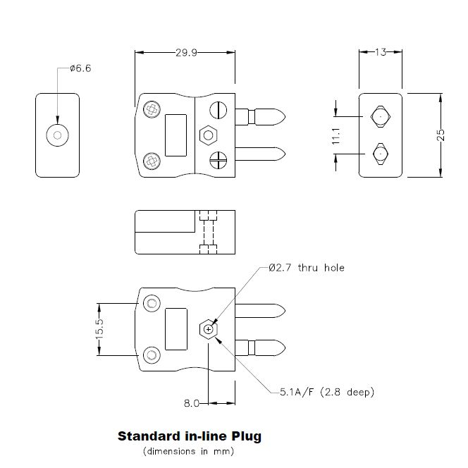

**Specifications**

|  |  |
| --- | --- |
| **General Description** | Contacts are polarised to prevent incorrect connection |
| **Thermocouple Type** | J IEC |
| **Connector Size** | Standard |
| **Connector Type** | Plug |
| **Colour** | Black |
| **Max. Temperature** | 220°C |
| **Pins** | Solid Round Pins |
| **+Positive Contact** | Iron |
| **-Negative Contact** | Copper Nickel |
| **Standards Met** | BS EN 50212:1997. RoHS |

**Ordering Information**

|  |  |  |  |  |  |
| --- | --- | --- | --- | --- | --- |
| **Thermocouple Type** | **Colour Code** | **Size** | **Style** | **Manufacturers Number** | **Order Number** |
| J | IEC | Standard | Plug | IS-J-M | XE-1460-001 |