**Standard Quick Wire Thermocouple Connector Socket IS-K-FQ Type K IEC**

XE-1412-001

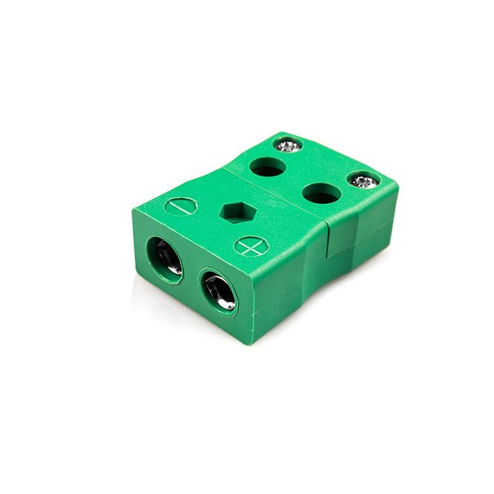

Labfacility are the UK’s leading manufacturer of Temperature Sensors, Thermocouple Connectors and associated Temperature Instrumentation and stockists of Thermocouple Cables. The Company has been trading since 1971 and is ISO 9001 accredited.

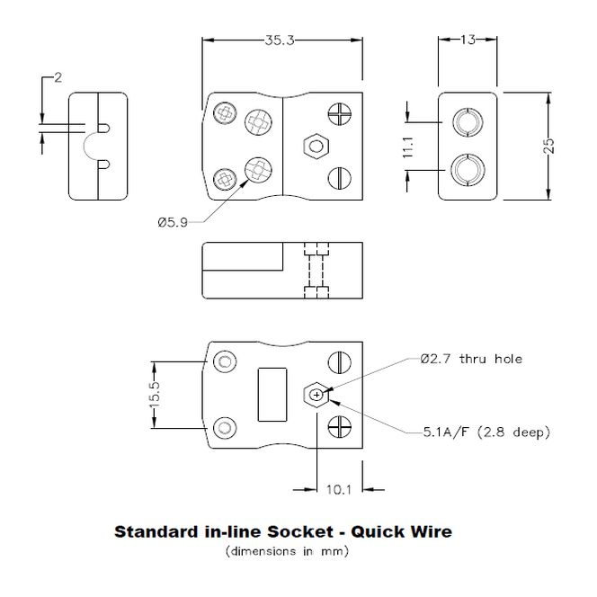

**Specifications**

|  |  |
| --- | --- |
| **General Description** | Easy 'jab-in' connection for rapid termination, contacts are polarised to prevent incorrect connection. |
| **Thermocouple Type** | K IEC |
| **Connector Type** | Quick Wire Socket |
| **Connector Size** | Standard |
| **Colour** | Green |
| **Max. Temperature** | 220°C |
| **+Positive Contact** | Nickel Chromium |
| **-Negative Contact** | Nickel Alloy |
| **Standards Met** | BS EN 50212:1997. RoHS |

**Ordering Information**

|  |  |  |  |  |  |
| --- | --- | --- | --- | --- | --- |
| **Thermocouple Type** | **Colour Code** | **Size** | **Style** | **Manufacturers Number** | **Order Number** |
| K | IEC | Standard | Quick Wire Socket | IS-K-FQ | XE-1412-001 |