**Standard Panel Mount Thermocouple Connector with Stainless Steel Bracket**

**IS-K-SSPF Type K IEC**

XE-1408-001

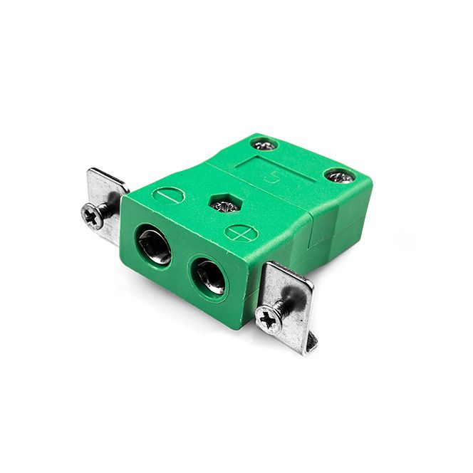

Labfacility are the UK’s leading manufacturer of Temperature Sensors, Thermocouple Connectors and associated Temperature Instrumentation and stockists of Thermocouple Cables. The Company has been trading since 1971 and is ISO 9001 accredited.

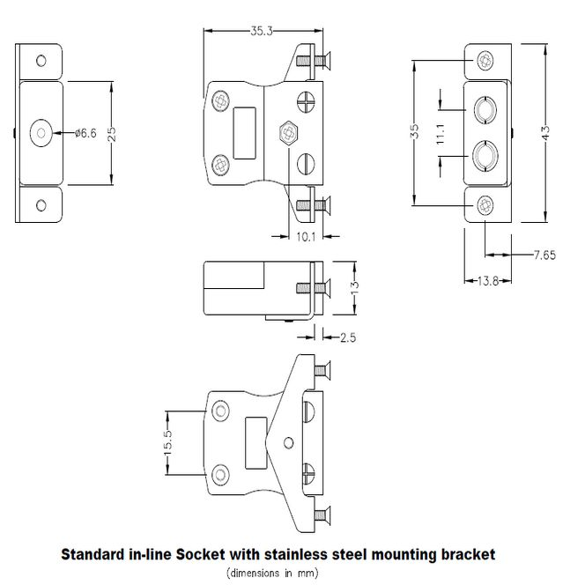

**Specifications**

|  |  |
| --- | --- |
| **General Description** | Intended for use in more industrial processes but can be used in all applications as desired. |
| **Thermocouple Type** | K IEC |
| **Connector Type** | Socket with Stainless Steel Bracket |
| **Connector Size** | Standard |
| **Colour** | Green |
| **Max. Temperature** | 220°C |
| **+Positive Contact** | Nickel Chromium |
| **-Negative Contact** | Nickel Alloy |
| **Standards Met** | BS EN 50212:1997. RoHS |

**Ordering Information**

|  |  |  |  |  |  |
| --- | --- | --- | --- | --- | --- |
| **Thermocouple Type** | **Colour Code** | **Size** | **Style** | **Manufacturers Number** | **Order Number** |
| K | IEC | Standard | Socket with Stainless Steel Bracket | IS-K-SSPF | XE-1408-001 |