**Standard Rectangular Fascia Thermocouple Connector Socket IS-K-FF Type K IEC**

XE-1407-001

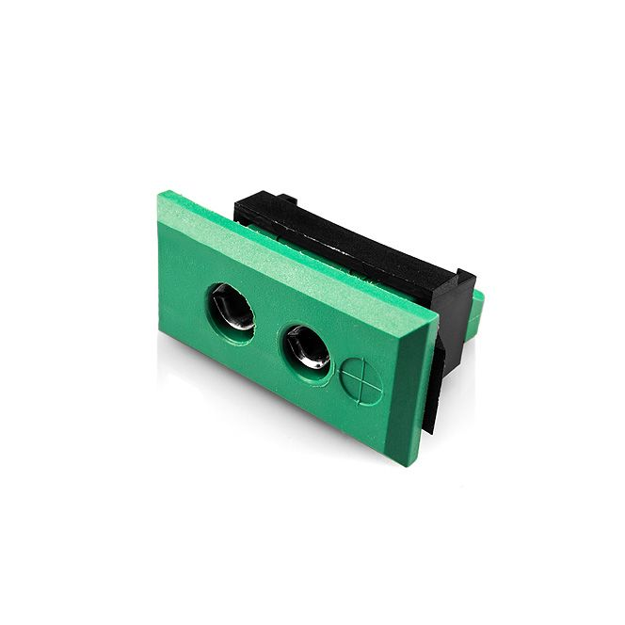

Labfacility are the UK’s leading manufacturer of Temperature Sensors, Thermocouple Connectors and associated Temperature Instrumentation and stockists of Thermocouple Cables. The Company has been trading since 1971 and is ISO 9001 accredited.

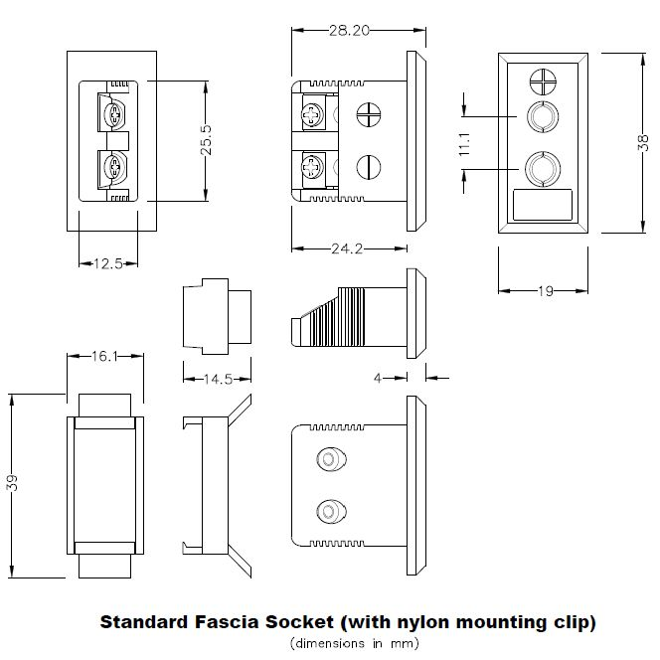

**Specifications**

|  |  |
| --- | --- |
| **General Description** | Accepts standard round pin plug connector. Nylon clip for quick, simple fixing to panel |
| **Thermocouple Type** | K IEC |
| **Connector Type** | Fascia Mounting Socket |
| **Connector Size** | Standard |
| **Colour** | Green |
| **Max. Temperature** | 120°C |
| **+Positive Contact** | Nickel Chromium |
| **-Negative Contact** | Nickel Alloy |
| **Standards Met** | BS EN 50212:1997. RoHS |

**Ordering Information**

|  |  |  |  |  |  |
| --- | --- | --- | --- | --- | --- |
| **Thermocouple Type** | **Colour Code** | **Size** | **Style** | **Manufacturers Number** | **Order Number** |
| K | IEC | Standard | Fascia Mounting Socket | IS-K-FF | XE-1407-001 |