**Miniature Quick Wire Thermocouple Connector Socket AM-K-FQ Type K ANSI**

XE-1142-001

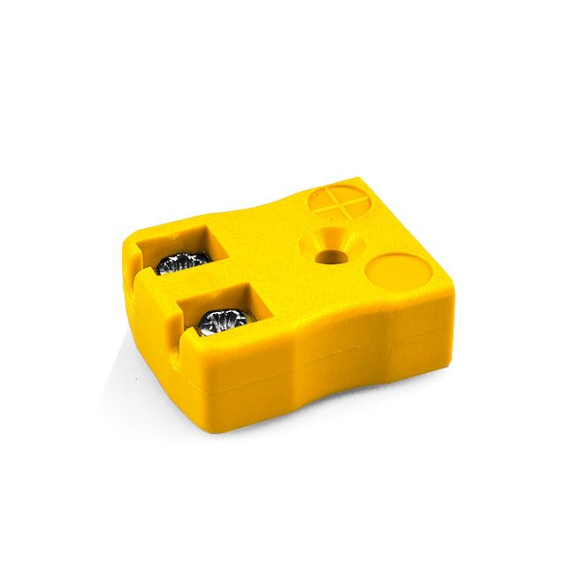

Labfacility are the UK’s leading manufacturer of Temperature Sensors, Thermocouple Connectors and associated Temperature Instrumentation and stockists of Thermocouple Cables. The Company has been trading since 1971 and is ISO 9001 accredited.

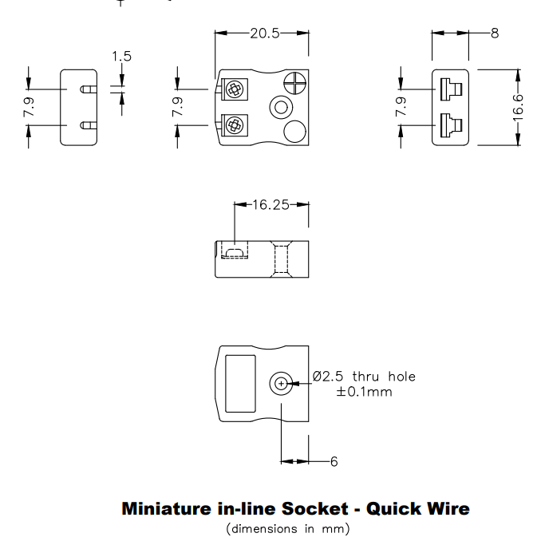

**Specifications**

|  |  |
| --- | --- |
| **General Description** | Easy jab-in connection, just push in wire & tighten screw. |
| **Thermocouple Type** | K ANSI |
| **Connector Type** | Quick Wire Socket |
| **Connector Size** | Miniature |
| **Colour** | Yellow |
| **Max. Temperature** | 220°C |
| **Pins** | Accepts Flat Pins |
| **+Positive Contact** | Nickel Chromium |
| **-Negative Contact** | Nickel Alloy |
| **Standards Met** | BS EN 50212:1997. RoHS |

**Ordering Information**

|  |  |  |  |  |  |
| --- | --- | --- | --- | --- | --- |
| **Thermocouple Type** | **Colour Code** | **Size** | **Style** | **Manufacturers Number** | **Order Number** |
| K | ANSI | Miniature | Quick Wire Socket | AM-K-FQ | XE-1142-001 |