**Miniature Quick Wire Thermocouple Connector Plug AM-K-MQ Type K ANSI**

XE-1141-001

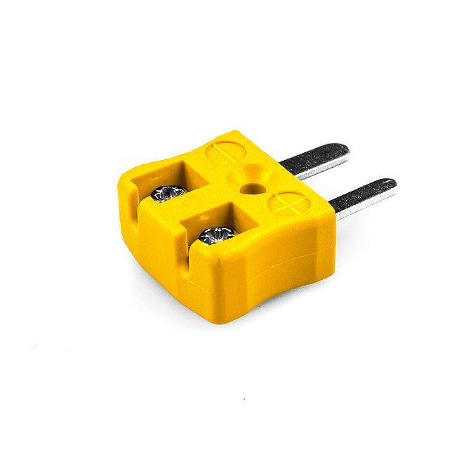

Labfacility are the UK’s leading manufacturer of Temperature Sensors, Thermocouple Connectors and associated Temperature Instrumentation and stockists of Thermocouple Cables. The Company has been trading since 1971 and is ISO 9001 accredited.

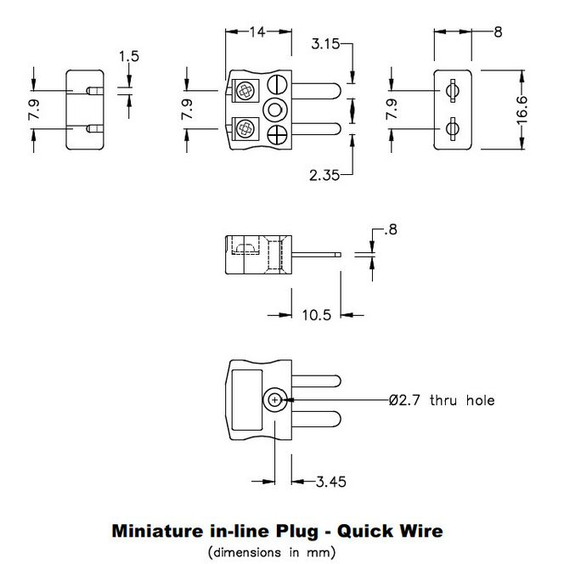

**Specifications**

|  |  |
| --- | --- |
| **General Description** | Easy jab-in connection for rapid termination. |
| **Thermocouple Type** | K ANSI |
| **Connector Type** | Quick Wire Plug |
| **Connector Size** | Miniature |
| **Colour** | Yellow |
| **Max. Temperature** | 220°C |
| **Pins** | Flat Pins |
| **+Positive Contact** | Nickel Chromium |
| **-Negative Contact** | Nickel Alloy |
| **Standards Met** | BS EN 50212:1997. RoHS |

**Ordering Information**

|  |  |  |  |  |  |
| --- | --- | --- | --- | --- | --- |
| **Thermocouple Type** | **Colour Code** | **Size** | **Style** | **Manufacturers Number** | **Order Number** |
| K | ANSI | Miniature | Quick Wire Plug | AM-K-MQ | XE-1141-001 |