**PCB Mounting Thermocouple Connector Socket IM-K-PCB Type K IEC**

XE-1109-001

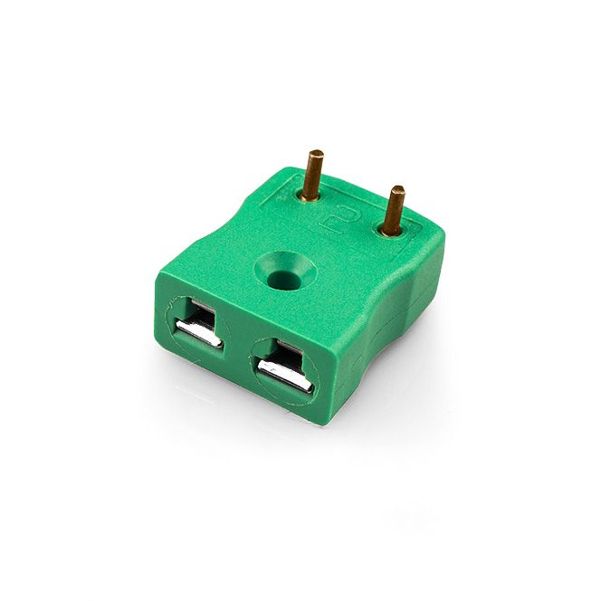

Labfacility are the UK’s leading manufacturer of Temperature Sensors, Thermocouple Connectors and associated Temperature Instrumentation and stockists of Thermocouple Cables. The Company has been trading since 1971 and is ISO 9001 accredited.

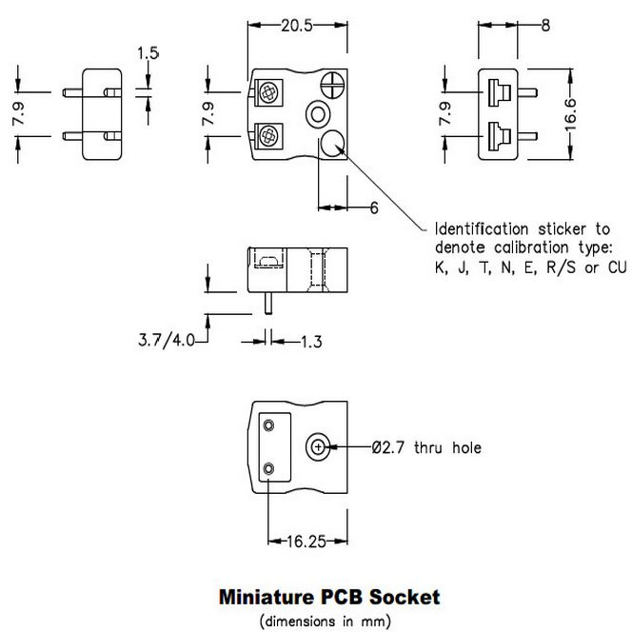

**Specifications**

|  |  |
| --- | --- |
| **General Description** | Versatile, high quality circuit board mounting miniature socket |
| **Thermocouple Type** | K IEC |
| **Connector Type** | PCB socket |
| **Connector Size** | Miniature |
| **Colour** | Green |
| **Max. Temperature** | 220°C |
| **+Positive Contact** | Nickel Chromium |
| **-Negative Contact** | Nickel Alloy |
| **Standards Met** | BS EN 50212:1997. RoHS |

**Ordering Information**

|  |  |  |  |  |  |
| --- | --- | --- | --- | --- | --- |
| **Thermocouple Type** | **Colour Code** | **Size** | **Style** | **Manufacturers Number** | **Order Number** |
| K | IEC | Miniature | PCB socket | IM-K-PCB | XE-1109-001 |