**Miniature Panel Mount Thermocouple Connector with Stainless Steel Bracket**

**IM-K-SSPF Type K IEC**

XE-1108-001

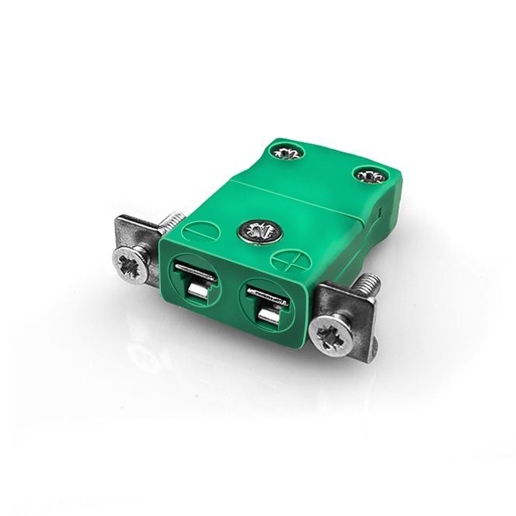

Labfacility are the UK’s leading manufacturer of Temperature Sensors, Thermocouple Connectors and associated Temperature Instrumentation and stockists of Thermocouple Cables. The Company has been trading since 1971 and is ISO 9001 accredited.

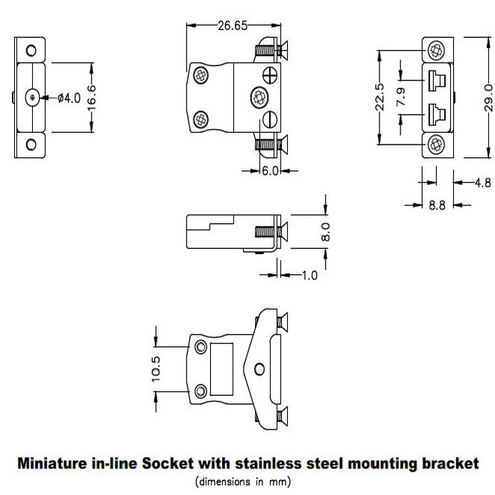

**Specifications**

|  |  |
| --- | --- |
| **General Description** | Fully enclosed terminals with cable port seal |
| **Thermocouple Type** | K IEC |
| **Connector Type** | Socket with Stainless steel Bracket |
| **Connector Size** | Miniature |
| **Colour** | Green |
| **Max. Temperature** | 220°C |
| **Pins** | Accepts Flat Pins |
| **+Positive Contact** | Nickel Chromium |
| **-Negative Contact** | Nickel Alloy |
| **Standards Met** | BS EN 50212:1997. RoHS |

**Ordering Information**

|  |  |  |  |  |  |
| --- | --- | --- | --- | --- | --- |
| **Thermocouple Type** | **Colour Code** | **Size** | **Style** | **Manufacturers Number** | **Order Number** |
| K | IEC | Miniature | Socket with Stainless steel Bracket | IM-K-SSPF | XE-1108-001 |