**Miniature Rectangular Thermocouple Connector Fascia Socket IM-K-FF Type K IEC**

XE-1107-001

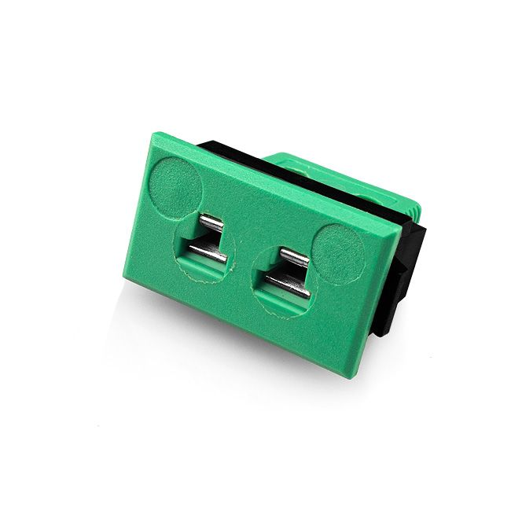

Labfacility are the UK’s leading manufacturer of Temperature Sensors, Thermocouple Connectors and associated Temperature Instrumentation and stockists of Thermocouple Cables. The Company has been trading since 1971 and is ISO 9001 accredited.

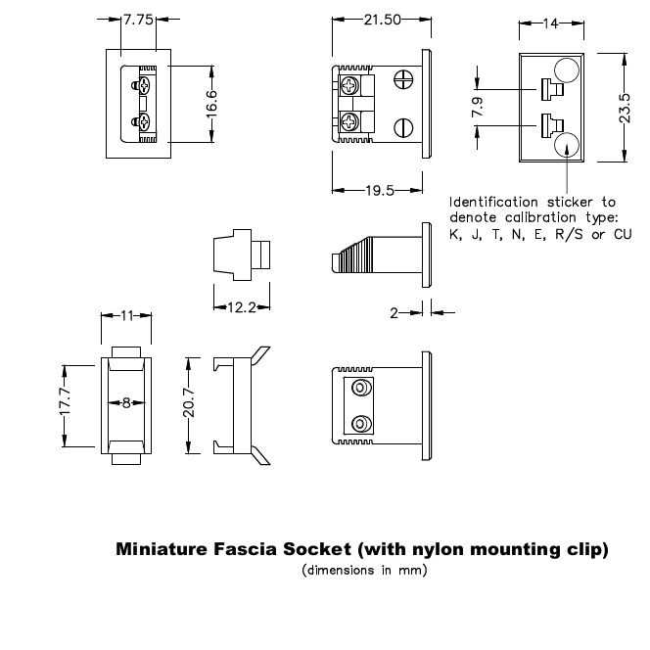

**Specifications**

|  |  |
| --- | --- |
| **General Description** | All fascia mounting sockets are polarised by means of unequally sized pins |
| **Thermocouple Type** | K IEC |
| **Connector Type** | Fascia mounting socket |
| **Connector Size** | Miniature |
| **Colour** | Green |
| **Max. Temperature** | 120°C |
| **+Positive Contact** | Nickel Chromium |
| **-Negative Contact** | Nickel Alloy |
| **Standards Met** | BS EN 50212:1997. RoHS |

**Ordering Information**

|  |  |  |  |  |  |
| --- | --- | --- | --- | --- | --- |
| **Thermocouple Type** | **Colour Code** | **Size** | **Style** | **Manufacturers Number** | **Order Number** |
| K | IEC | Miniature | Fascia mounting socket | IM-K-FF | XE-1107-001 |