XE-1106-001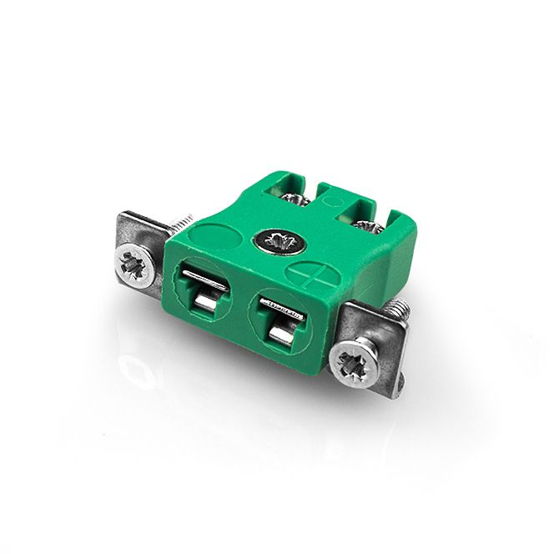

**Miniature Quick Wire Thermocouple Connector Panel Mount with Stainless Steel Bracket**

**IM-K-SSPFQ Type K IEC**

XE-1106-001

Labfacility are the UK’s leading manufacturer of Temperature Sensors, Thermocouple Connectors and associated Temperature Instrumentation and stockists of Thermocouple Cables. The Company has been trading since 1971 and is ISO 9001 accredited.

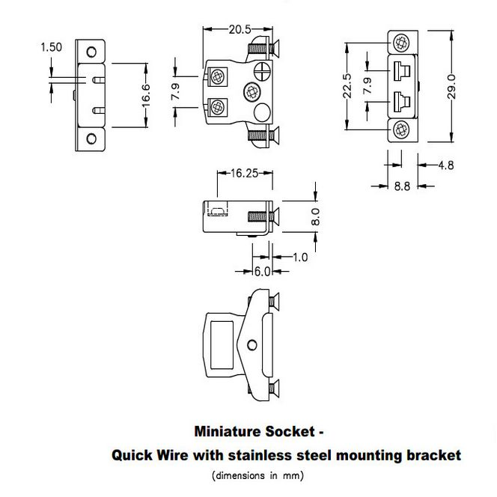

**Specifications**

|  |  |
| --- | --- |
| **General Description** | Contacts are polarized to ensure correct connection |
| **Thermocouple Type** | K IEC |
| **Connector Type** | Quick Wire Socket with SS Bracket |
| **Connector Size** | Miniature |
| **Colour** | Green |
| **Max. Temperature** | 220°C |
| **+Positive Contact** | Nickel Chromium |
| **-Negative Contact** | Nickel Alloy |
| **Standards Met** | BS EN 50212:1997. RoHS |

**Ordering Information**

|  |  |  |  |  |  |
| --- | --- | --- | --- | --- | --- |
| **Thermocouple Type** | **Colour Code** | **Size** | **Style** | **Manufacturers Number** | **Order Number** |
| K | IEC | Miniature | Quickwire Stainless Steel Bracket | IM-K-SSPFQ | XE-1106-001 |