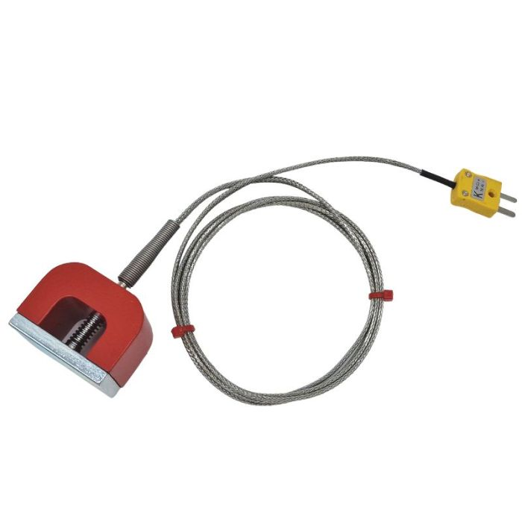

**ANSI Type K 11.8kg Pull Power (Horseshoe) Magnet Thermocouple, PFA Insulated Cable with Stainless Steel Over-Braid Terminating in Miniature Plug, 3m**

XE-0671-001

Labfacility are the UK’s leading manufacturer of Temperature Sensors, Thermocouple Connectors and associated Temperature Instrumentation and stockists of Thermocouple Cables. The Company has been trading since 1971 and is ISO 9001 accredited.

**Specifications**

|  |  |
| --- | --- |
| **General Description** | 11.8kg Pull Power (Horseshoe) Magnet Thermocouple |
| **Sensor Type** | Magnet Thermocouple |
| **Thermocouple Type** | K |
| **Magnet** | 45 x 30 x 30mm (L x H x W) - Max pull: 11.8 KG |
| **Cable Length** | 3m |
| **Cable Type** | PFA Insulated Cable with Stainless Steel Over-Braid |
| **Core / Strands** | 7/0.2mm |
| **Cable Termination** | Miniature or Standard Plug |
| **Max. Temperature** | +250°C |
| **Min. Temperature** | -50°C |
| **Standards Met** | ANSI MC96.1 |

**Ordering Information**

|  |  |  |  |  |  |
| --- | --- | --- | --- | --- | --- |
| **Thermocouple Type** | **Colour Code** | **Magnet Pull** | **Length** | **Termination** | **Order Number** |
| K | ANSI | 11.8kg | 3m | Miniature Plug | XE-0671-001 |