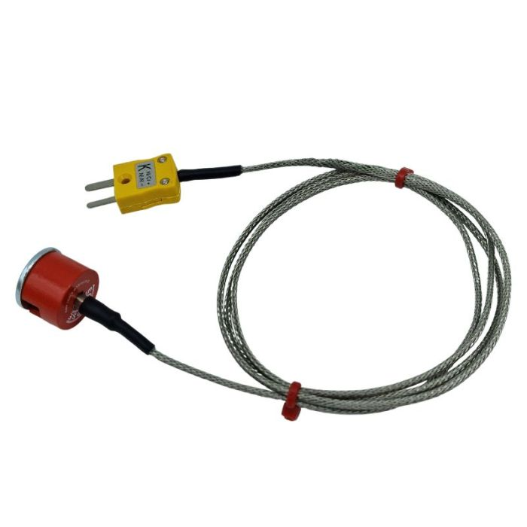

**ANSI Type K 1.9kg Pull Button Magnet Thermocouple, PFA Insulated Cable with Stainless Steel Over-Braid Terminating in Miniature Plug, 1m**

XE-0620-001

Labfacility are the UK’s leading manufacturer of Temperature Sensors, Thermocouple Connectors and associated Temperature Instrumentation and stockists of Thermocouple Cables. The Company has been trading since 1971 and is ISO 9001 accredited.

**Specifications**

|  |  |
| --- | --- |
| **General Description** | 1.9kg Pull Button Magnet Thermocouple |
| **Thermocouple Type** | K |
| **Magnet** | 19.1mm Diameter / 12.7mm height |
| **Cable Length** | 1.0m |
| **Cable Type** | Glassfibre insulated lead with stainless steel overbraid 7/0.2mm |
| **Termination Type** | Miniature Plug |
| **Max. Temperature** | 250°C |
| **Min. Temperature** | -50°C |
| **Standards Met** | ANSI |

**Ordering Information**

|  |  |  |  |  |  |
| --- | --- | --- | --- | --- | --- |
| **Thermocouple Type** | **Colour Code** | **Magnet Pull** | **Length** | **Termination** | **Order Number** |
| K | ANSI | 1.9kg | 1m | Miniature Plug | XE-0620-001 |