**PTFE insulated Twin Twisted IEC Exposed Junction Thermocouple with Miniature Plug - Type K, 10m**

XE-0417-001

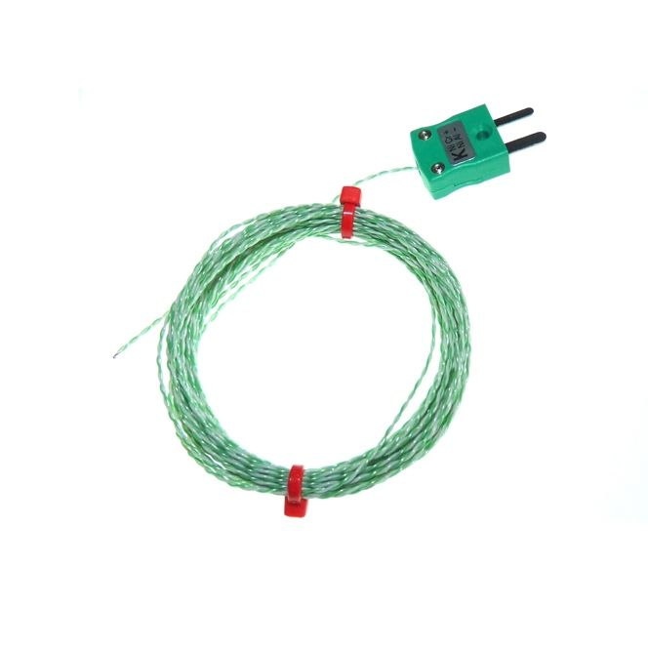

Labfacility are the UK’s leading manufacturer of Temperature Sensors, Thermocouple Connectors and associated Temperature Instrumentation and stockists of Thermocouple Cables. The Company has been trading since 1971 and is ISO 9001 accredited.

**Specifications**

|  |  |
| --- | --- |
| **General Description** | Fast response, welded exposed junction |
| **Sensor Type** | Exposed Junction |
| **Thermocouple Type** | K |
| **Cable Length** | 10m |
| **Cable Type** | Teflon® PTFE insulated twin-twisted lead |
| **Core / Strands** | 1/0.2mm |
| **Termination Type** | Miniature flat pin plug colour coded in accordance IEC 584 |
| **Max. Temperature** | +260°C |
| **Min. Temperature** | -75°C |
| **Tolerance** | Class 1 |
| **Standards Met** | IEC-584-3 |
| **Connector Type** | Plug |
| **Connector Size** | Miniature |

**Ordering Information**

|  |  |  |  |  |  |
| --- | --- | --- | --- | --- | --- |
| **Thermocouple Type** | **Colour Code** | **Core/Strands** | **Length** | **Termination** | **Order Number** |
| K | IEC | 1/0.2mm | 10m | Miniature Plug | XE-0417-001 |