**PFA Insulated Twin Twisted IEC Exposed Junction thermocouple with Moulded-on Plug - Type K, 3m**

XE-0021-001

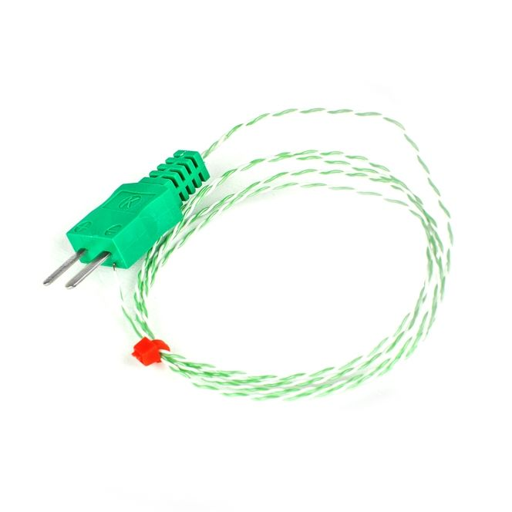

Labfacility are the UK’s leading manufacturer of Temperature Sensors, Thermocouple Connectors and associated Temperature Instrumentation and stockists of Thermocouple Cables. The Company has been trading since 1971 and is ISO 9001 accredited.

**Specifications**

|  |  |
| --- | --- |
| **General Description** | Good mechanical strength and flexibility, resistant to oils, acids and other adverse fluids, gasses, steam etc. |
| **Sensor Type** | Exposed Junction |
| **Thermocouple Type** | K |
| **Cable Length** | 3m |
| **Cable Type** | PFA insulated conductors twisted together |
| **Core / Strands** | 1/0.3mm |
| **Termination Type** | Miniature moulded flat pin plug, colour coded ‘green’ in accordance IEC specification |
| **Max. Temperature** | +260°C |
| **Min. Temperature** | -75°C |
| **Tolerance** | Class 1 |
| **Standards Met** | Colour code (cores & jacket) to IEC-584-3 |
| **Connector Type** | Plug |
| **Connector Size** | Miniature (moulded-on) |

**Ordering Information**

|  |  |  |  |  |  |
| --- | --- | --- | --- | --- | --- |
| **Thermocouple Type** | **Colour Code** | **Core/Strands** | **Length** | **Termination** | **Order Number** |
| K | IEC | 1/0.3mm | 3m | Miniature Moulded-on Plug | XE-0021-001 |