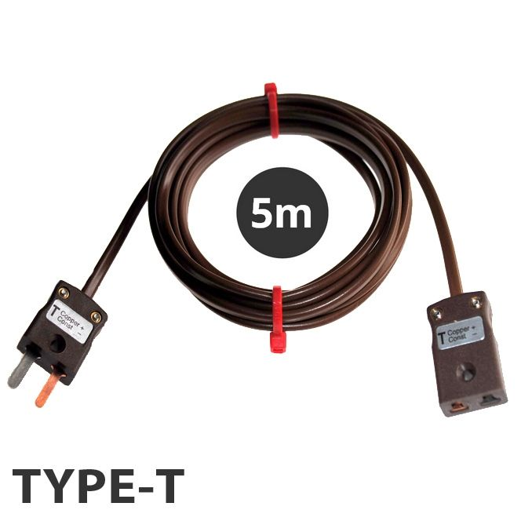

**Type T PVC Extension Leads with Miniature Plug & Socket (IEC) – 5m**

XE-7007-001

Labfacility are the UK’s leading manufacturer of Temperature Sensors, Thermocouple Connectors and associated Temperature Instrumentation and stockists of Thermocouple Cables. The Company has been trading since 1971 and is ISO 9001 accredited.

**Specifications**

|  |  |
| --- | --- |
| **General Description** | Good general purpose insulation for 'light' environments. Waterproof and very flexible. |
| **Cable Length** | 5M |
| **Cable Type** | Flat Pair Construction |
| **Connector Type** | Thermocouple Plug & Socket |
| **Connector Size** | Miniature |
| **Core / Strands** | 7/0.2mm |
| **Conductor Cross Section 7/0.2 (mm2)** | 0.219 |
| **Outer Colour** | Brown |
| **Drain Wire** | No |
| **Insulation Material** | PVC Insulated |
| **Loop Resistance 7/0.2 (Ohms per combined metre)** | 4.5 |
| **Max. Temperature** | +105°C |
| **Min. Temperature** | -10°C |
| **+ Conductor** | Copper |
| **- Conductor** | Constantan |
| **Screen** | No |
| **Standards Met** | Colour code (cores & jacket) to IEC-584-3 |
| **Thermocouple Type** | T |
| **Termination Type** | Miniature Thermocouple Plug and Socket |
| **Tolerance** | Class 2 |

**Ordering Information**

|  |  |  |  |
| --- | --- | --- | --- |
| **Type** | **Length** | **Termination** | **Order Number** |
| T | 5m | Miniature Plug & Socket | XE-7007-001 |