1. On first generation E10 boards, remove jumper J5. Connect the micro USB cable to J6 on the board.

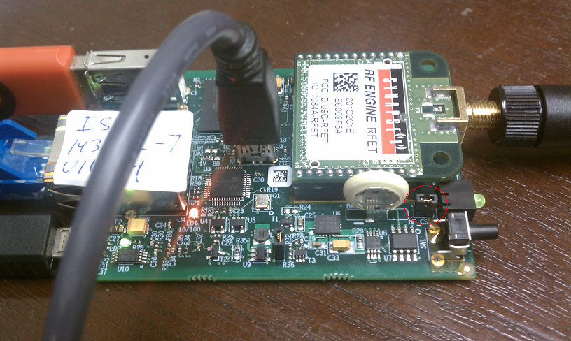

1. On second generation E10 boards, connect jumper J5 between pins 1 and 2. Connect the micro USB cable to J6 on the board.

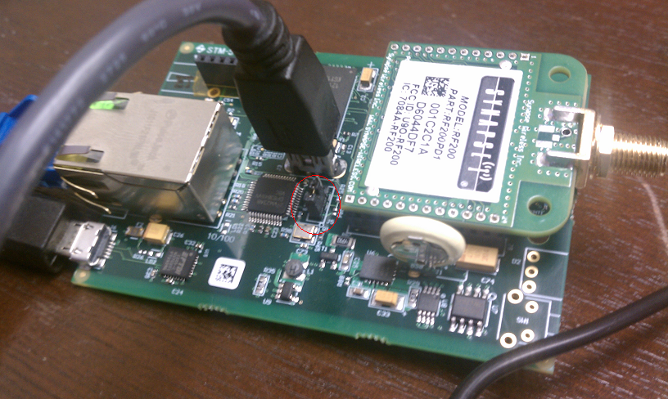

1. On first generation E10 boards, replace jumper J5. On second generation E10 boards, remove jumper J5.